**Install GIT & make sure it is added into PATH**.(Done)

Section 0 -Use GIT as local VCS. Steps to follow:

1. **Create a directory ‘project_dir’ & cd to ‘project_dir’.**

mkdir project_dir

cd project_dir

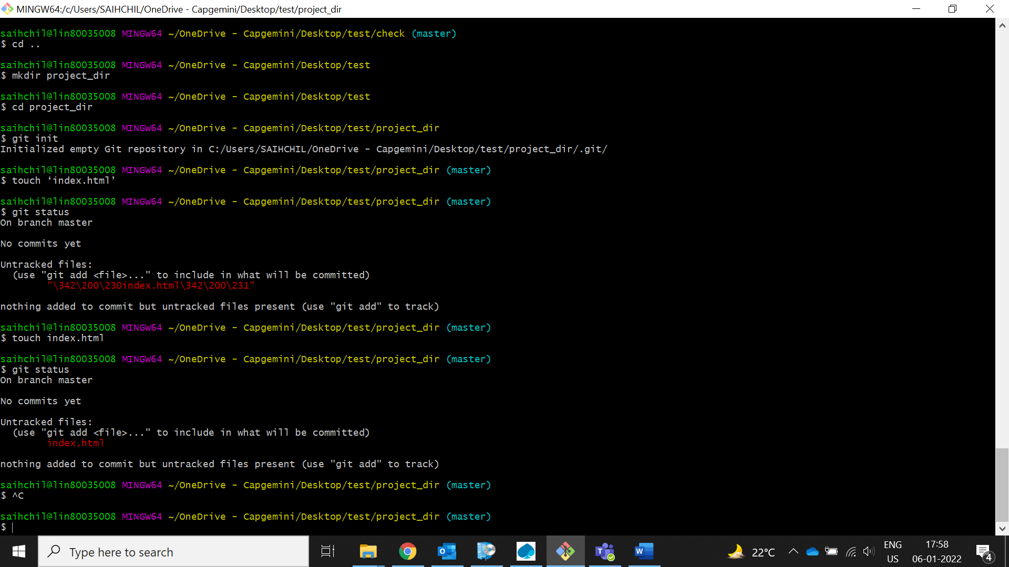

1. **Initialize git version database. (git init)**

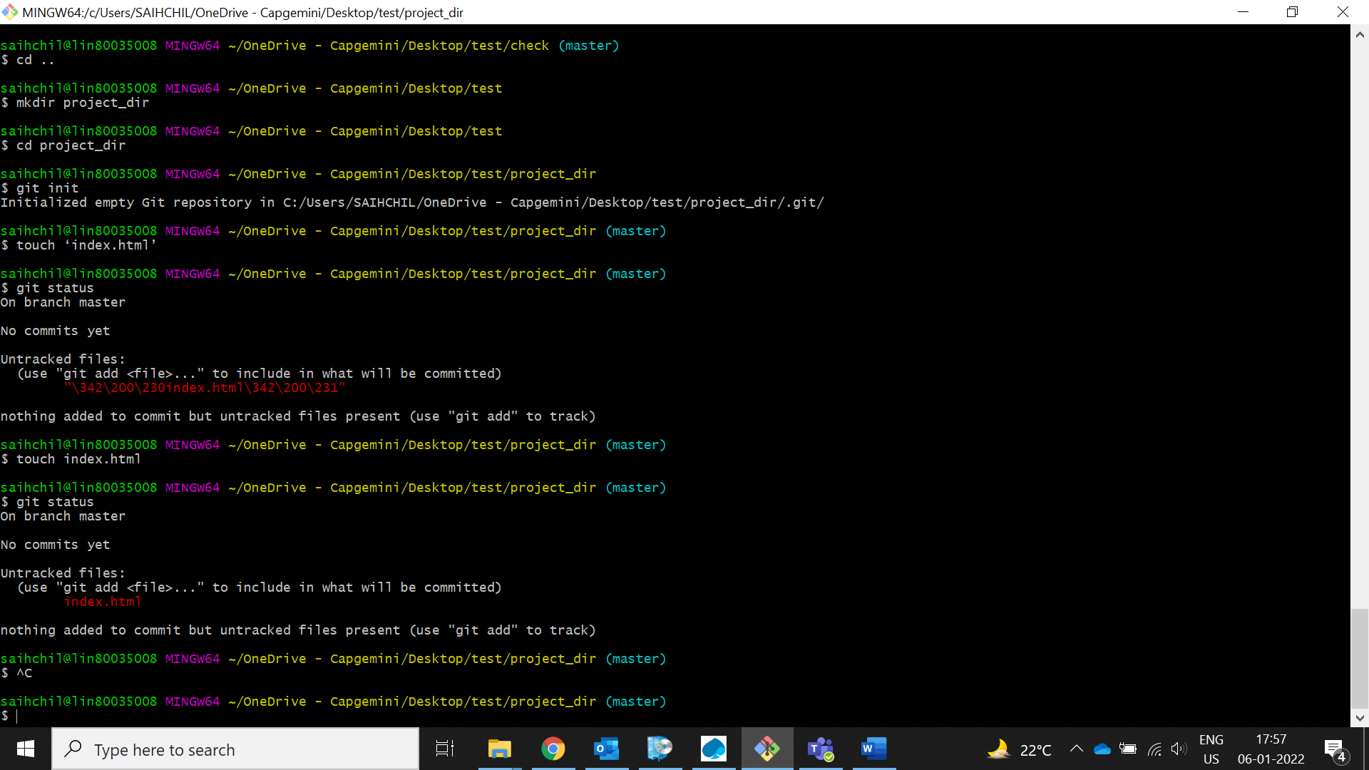

1. **Create a new file index.html.**

touch index.html



1. **Check the git status. You should find index.html as untracked file.**

Without adding index.html file to staged area we will get index.html as untracked file

git status



1. **Stage the index.html file.**

git add index.html

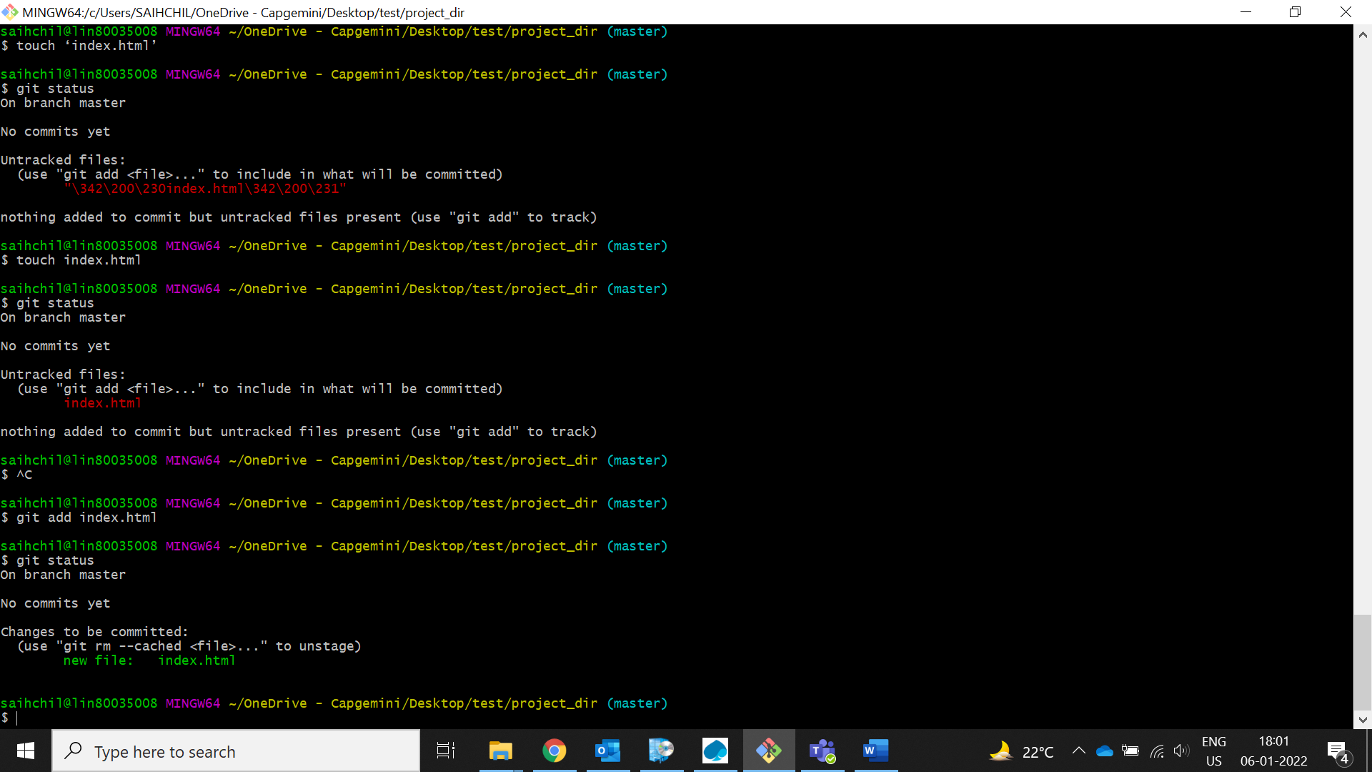

1. **Commit index.html**

git commit -m ‘first commit’

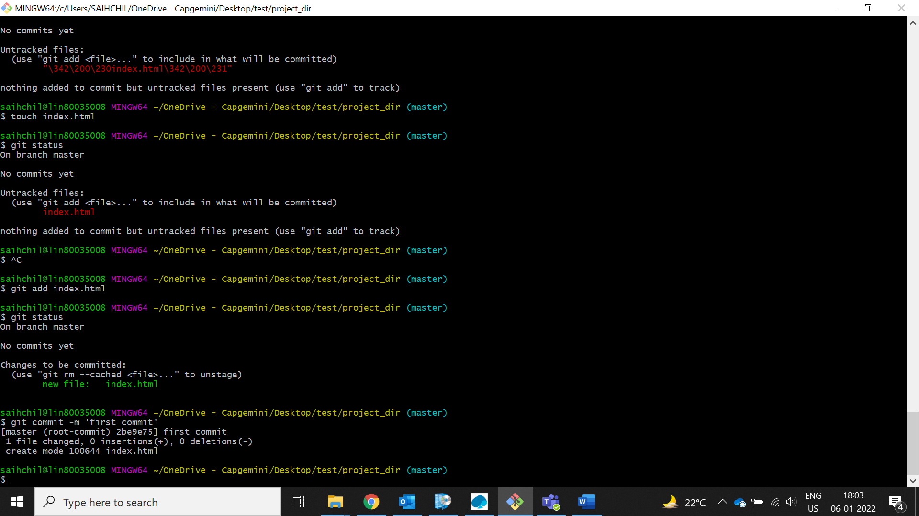

1. **Make few changes in index.html & create a new file info.txt file.**

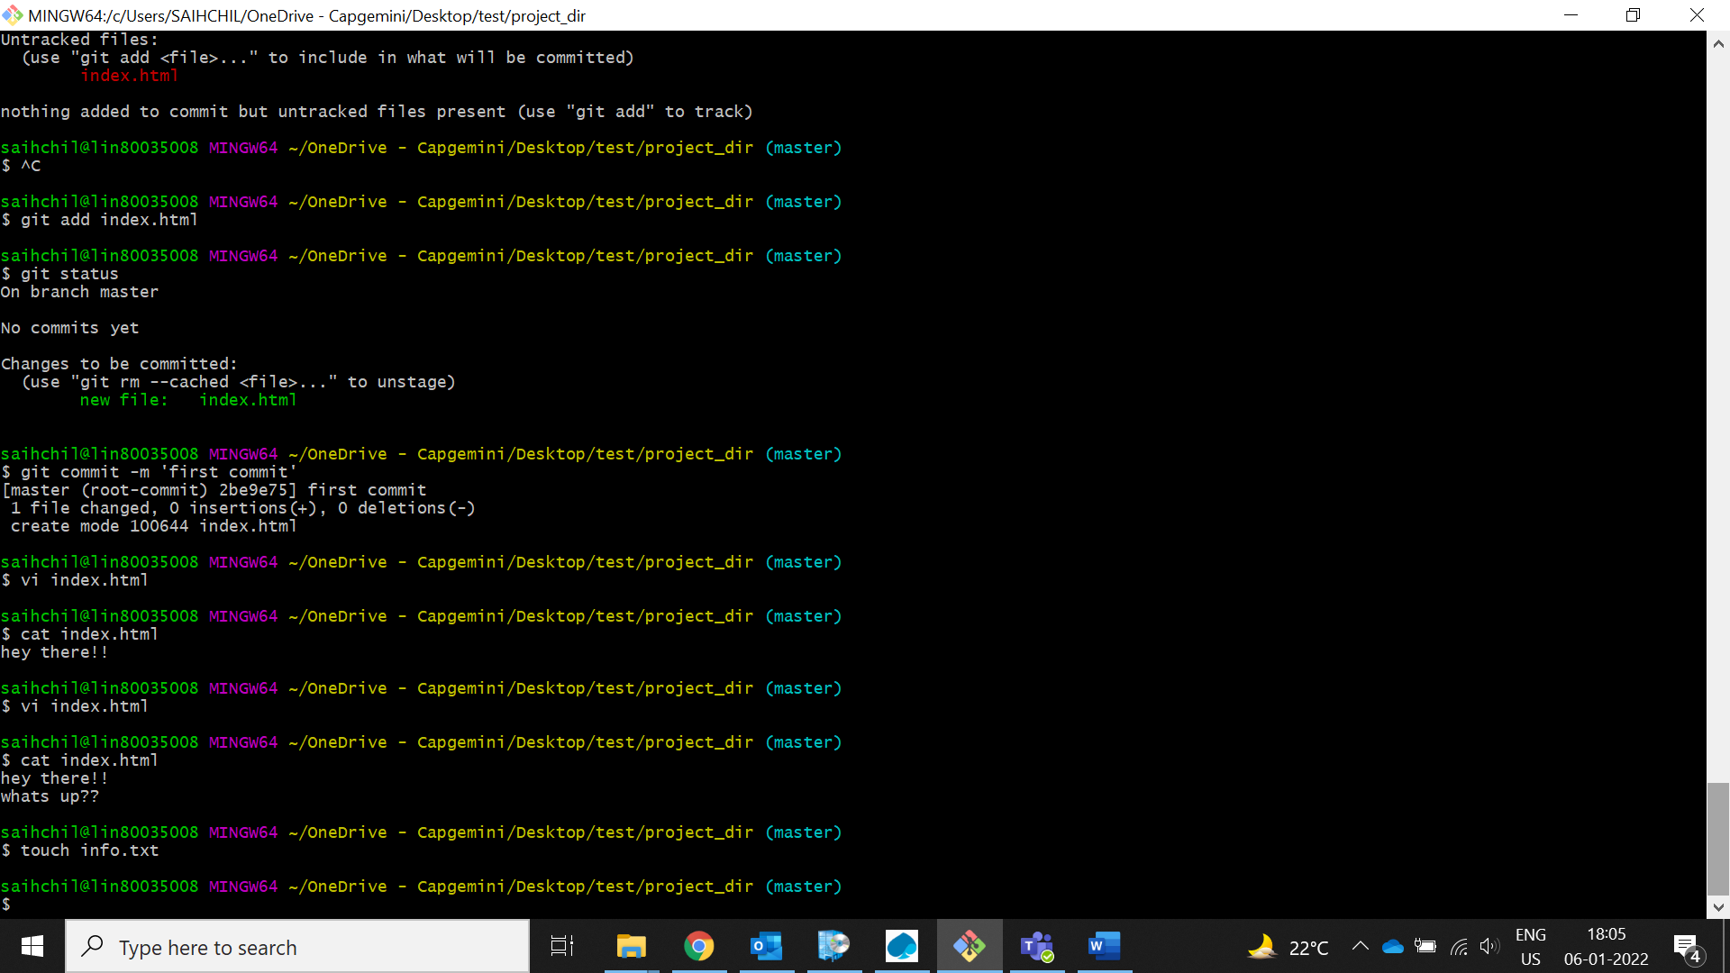

vi index.html (make changes)

:wq! (save and exit)

touch ‘info.txt’ (created a text file)

1. **Check git status. You should find index.html & info.txt as untracked files.**

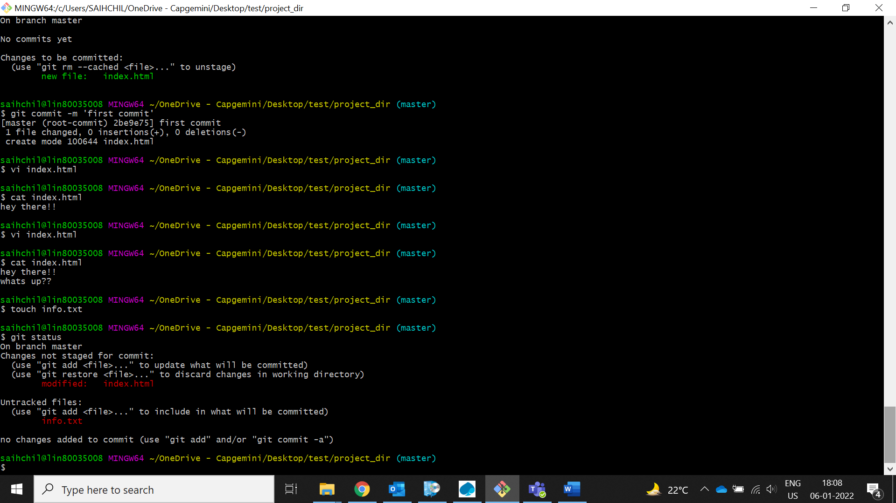

1. **Configure GIT to ignore all txt files.**

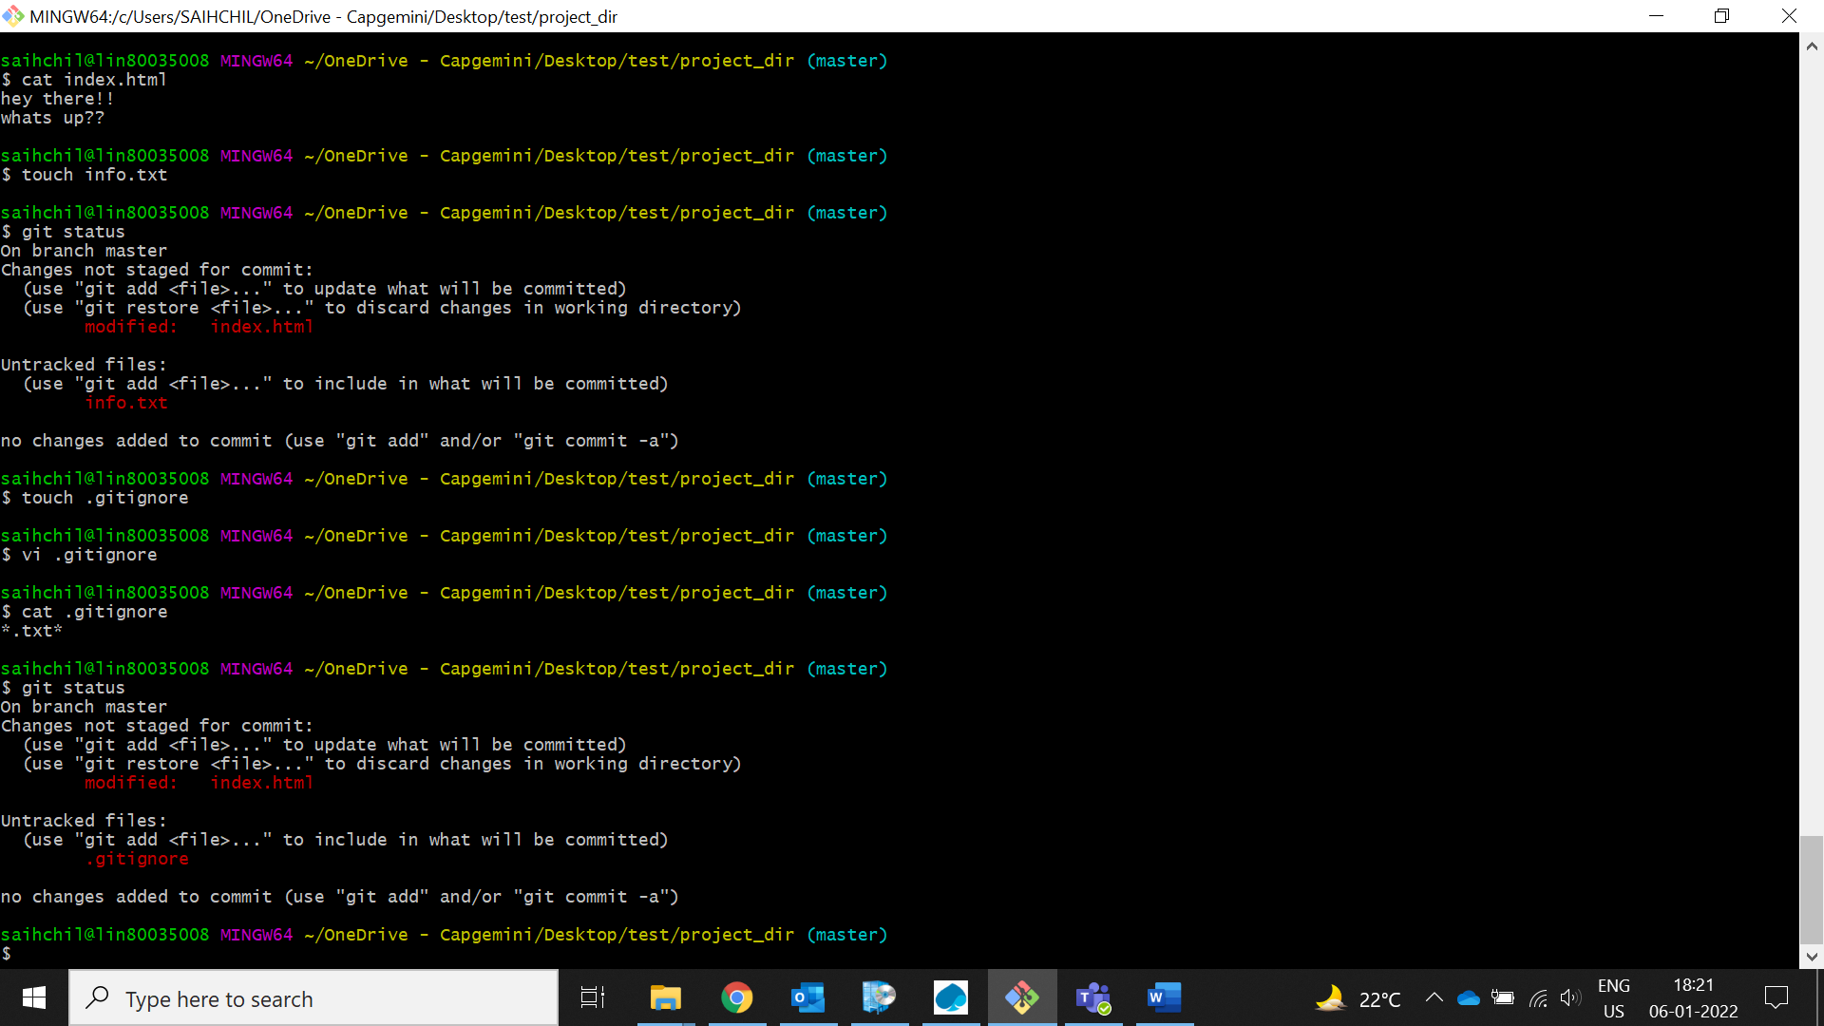

1. **Again check the git status. You should find only index.html as untracked file.**

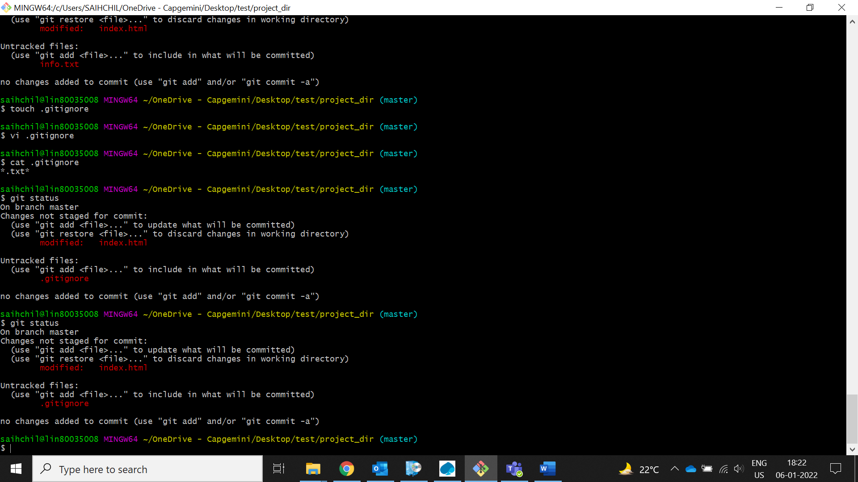

1. **State & commit index.html**

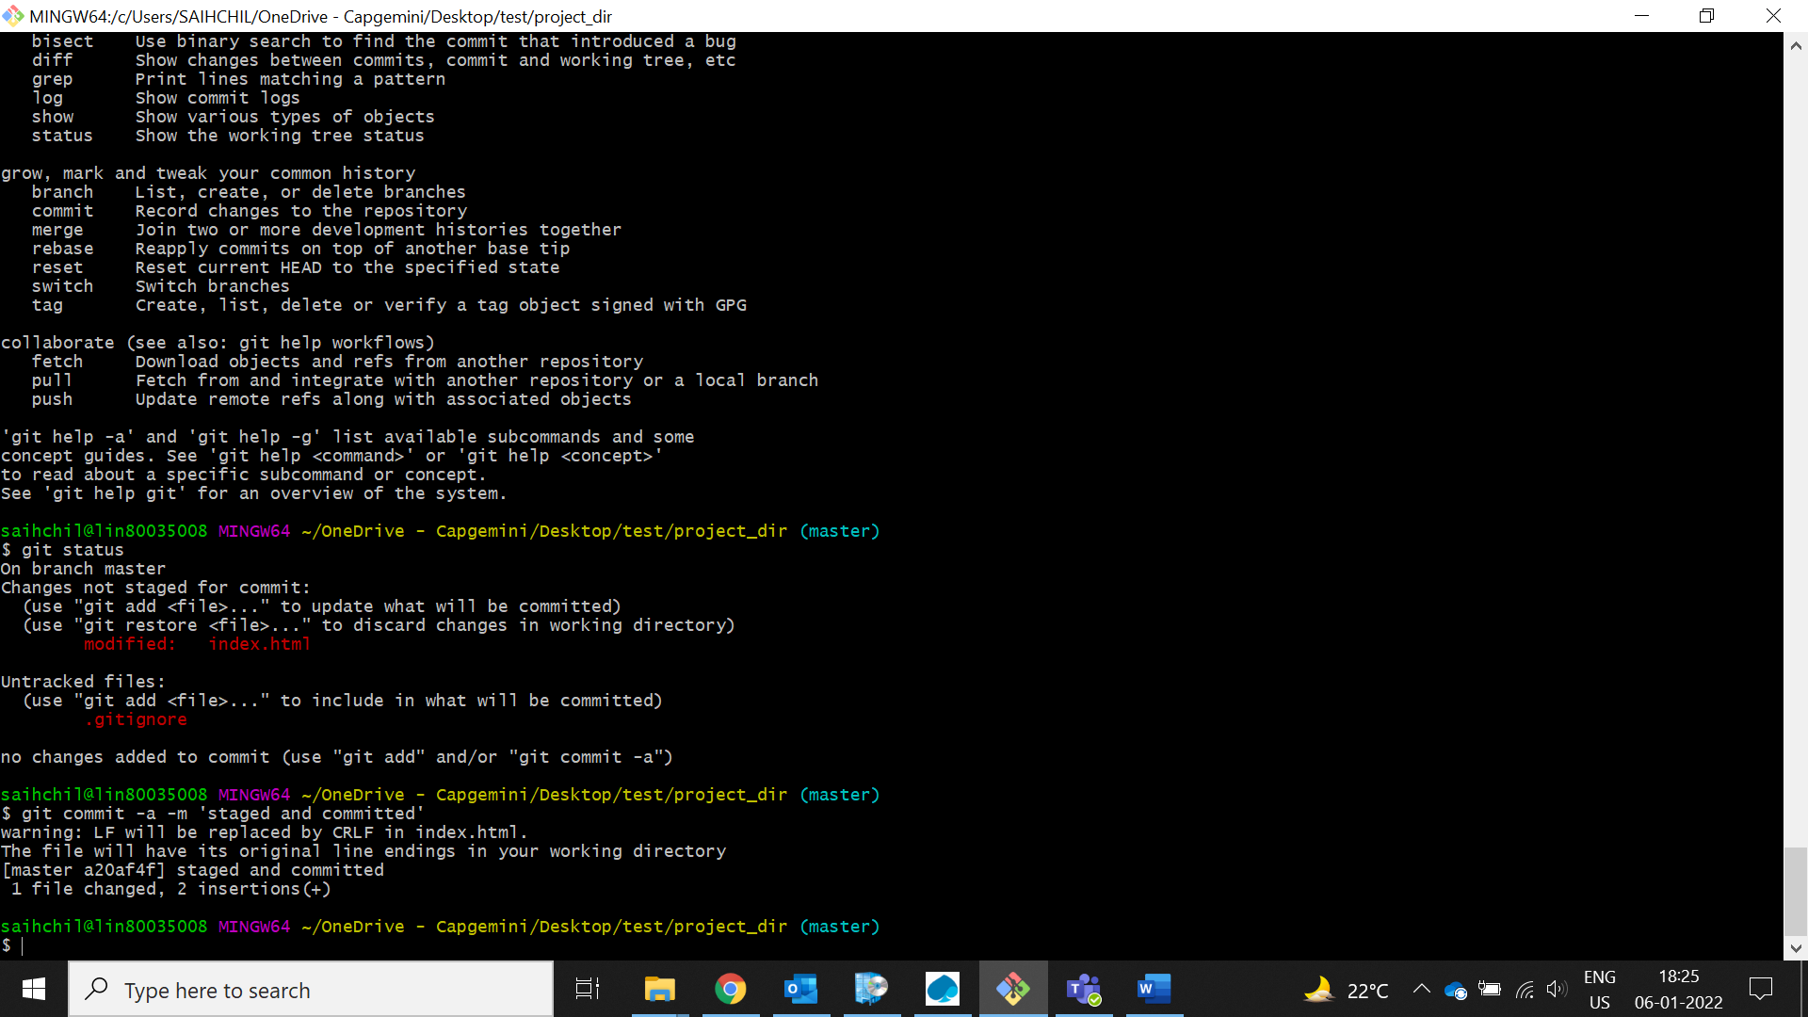

1. **Log all your comments so far.**

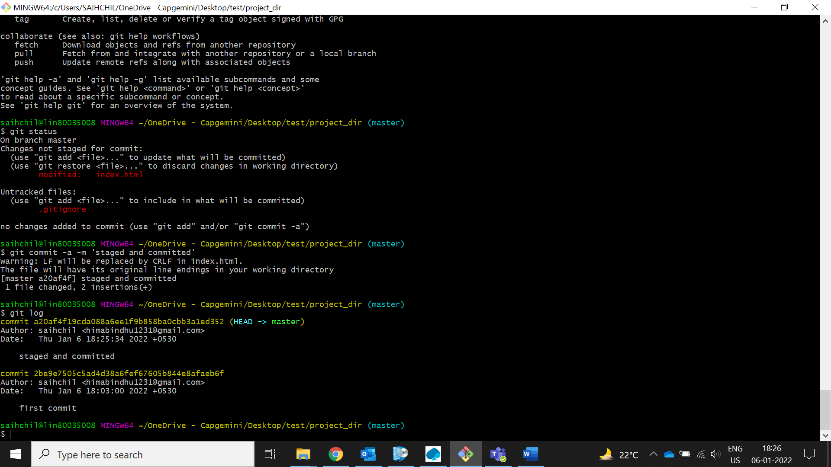

1. **Make some changes in index.html.**

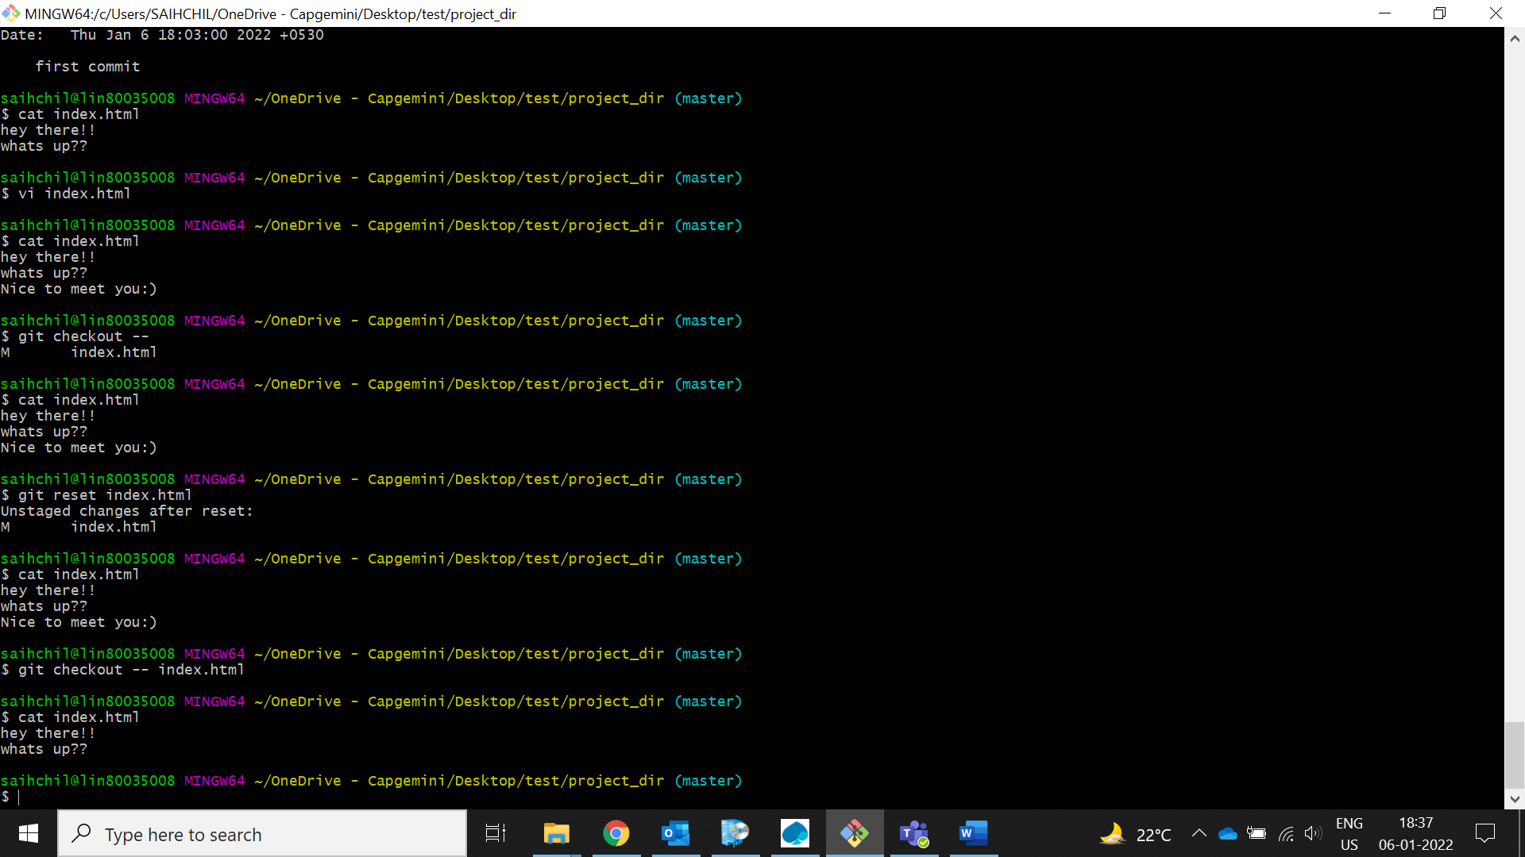

1. **Revert the change made in the previous step using git command.**

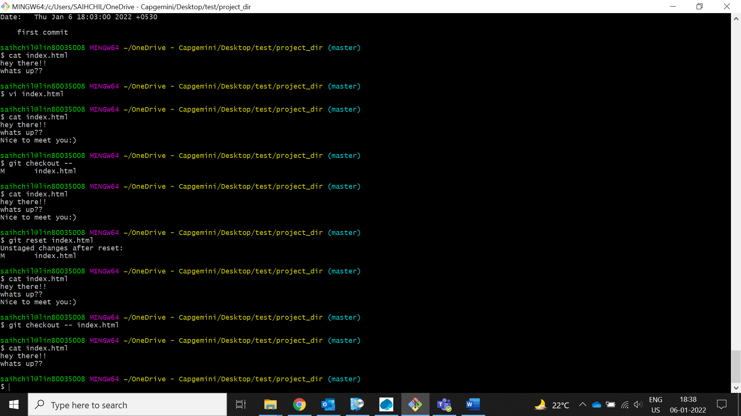

1. **Again change index.html.**

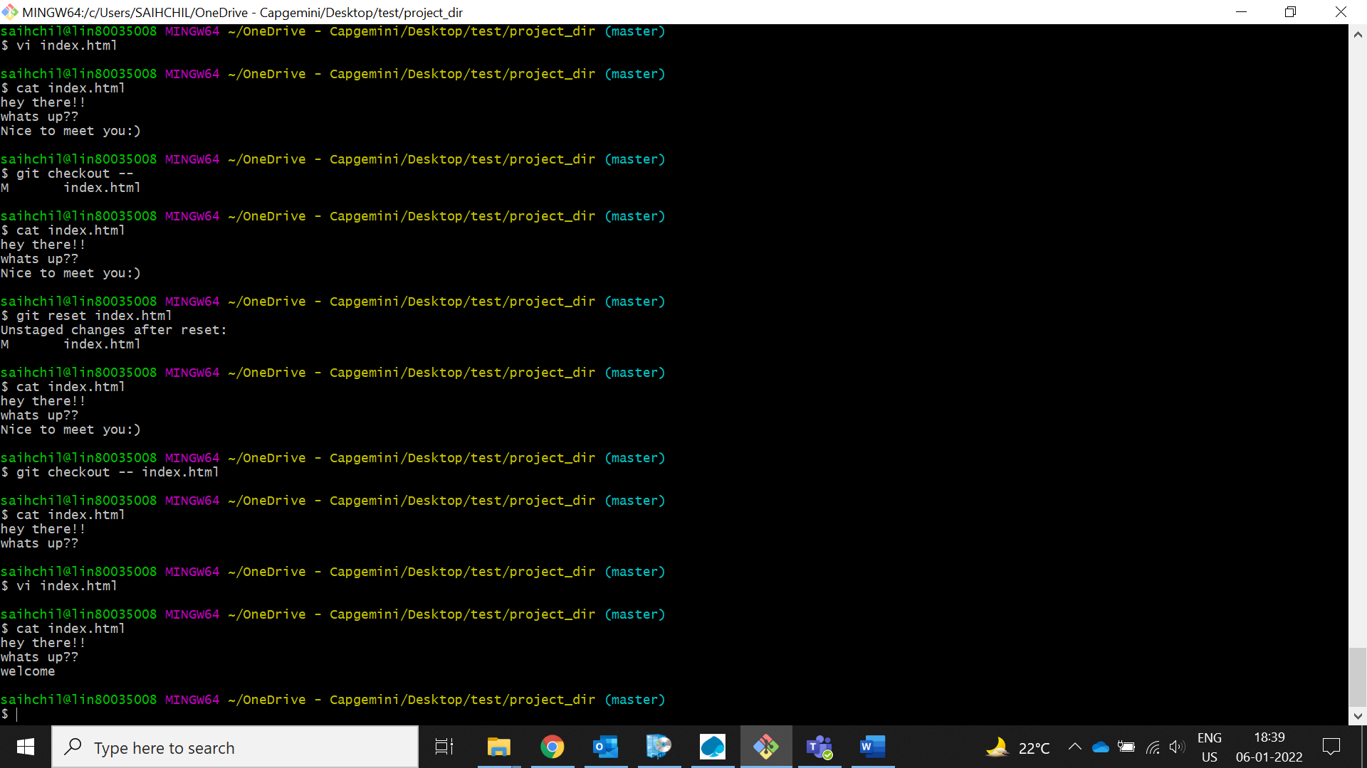

1. **Stage index.html**

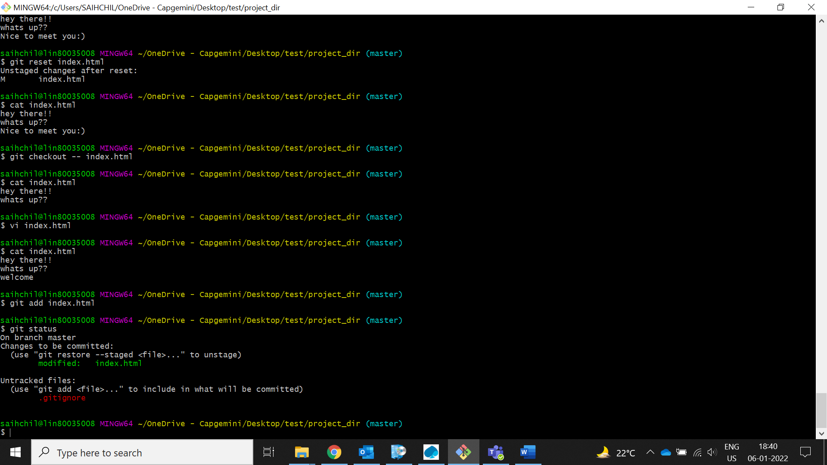

1. **Revert back the last stage.**

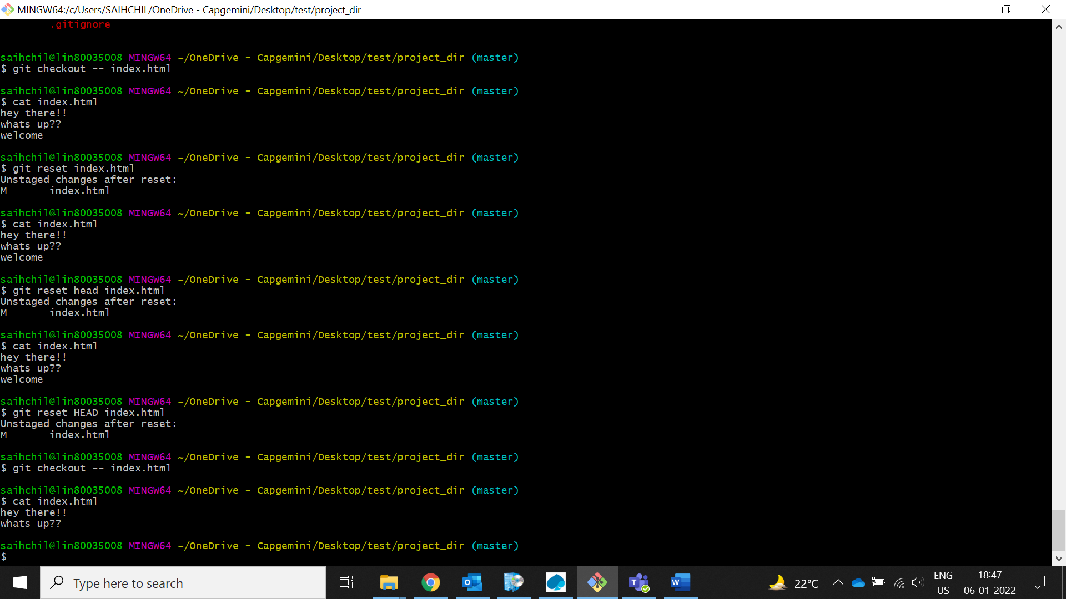

1. **Rename ‘add’ command to ‘my-add’.**

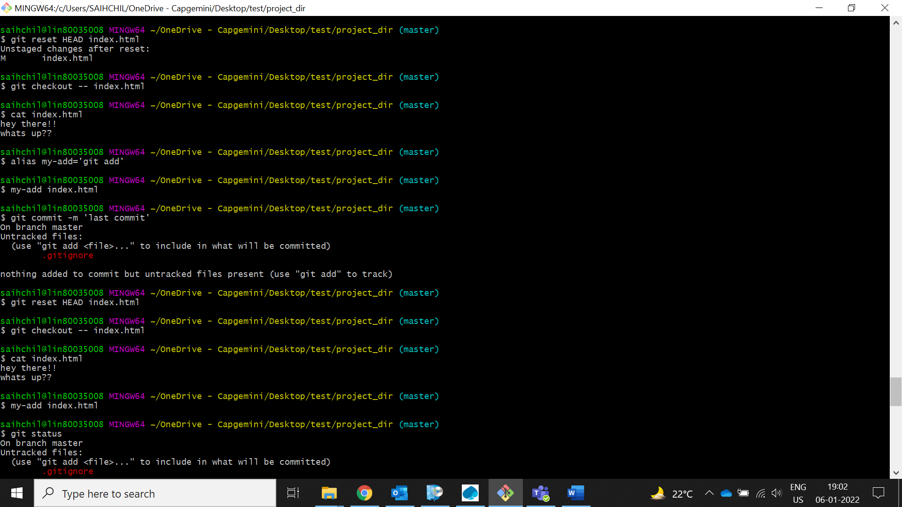

1. **Using my_add command Stage index.html again & commit the changes.**

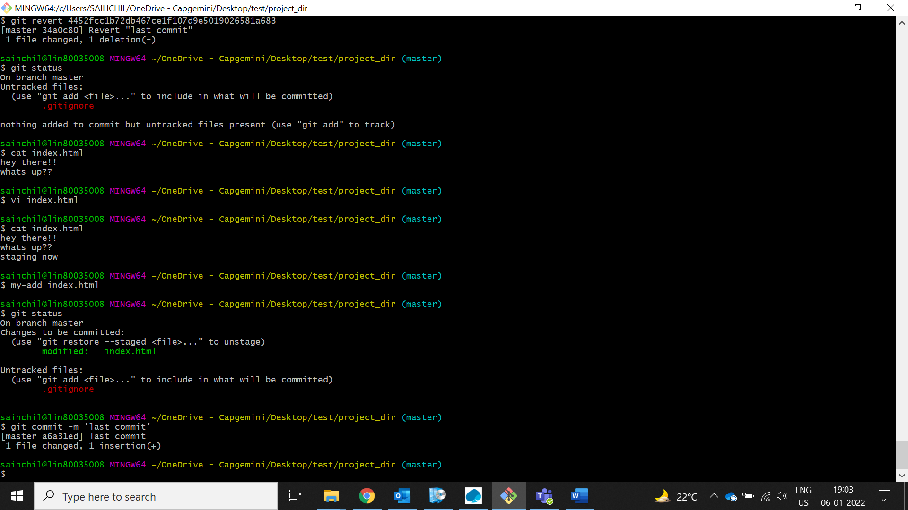

1. **Revert the last commit.**

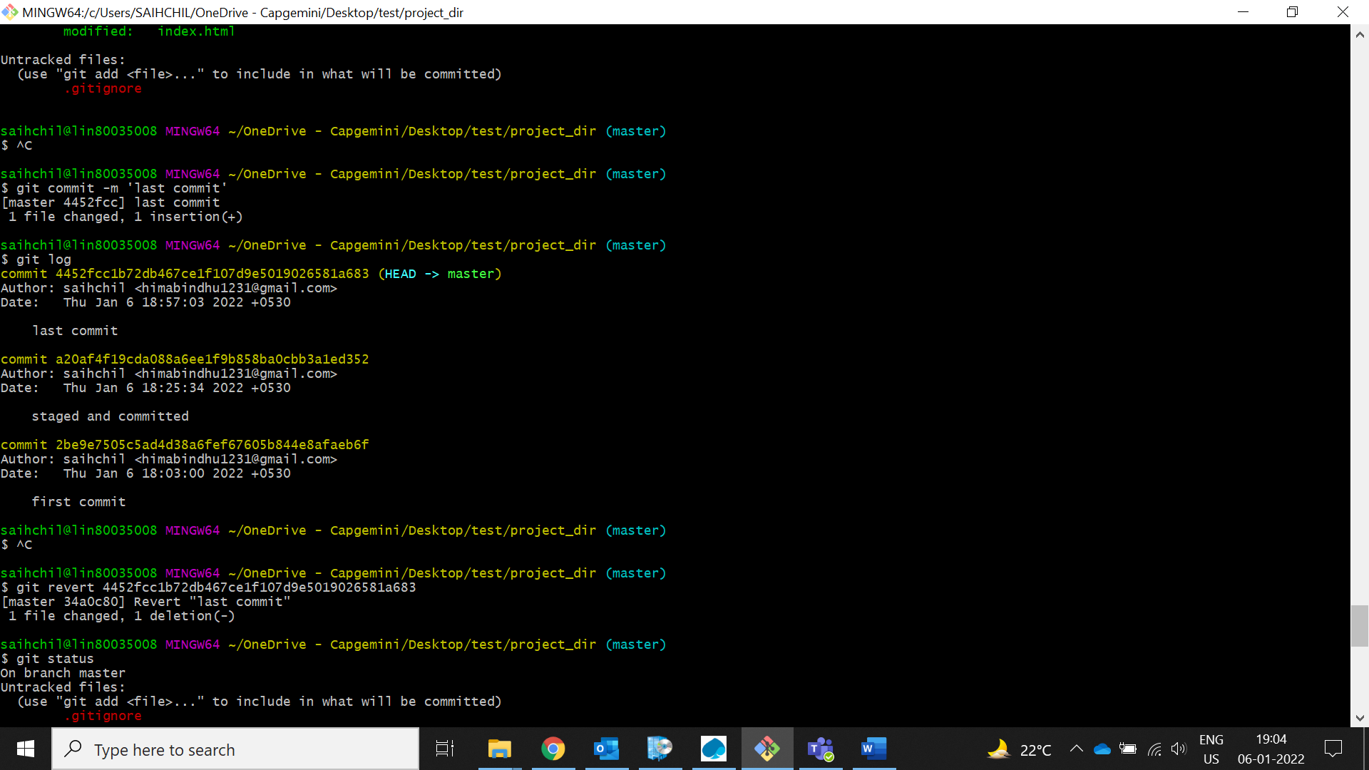

*GIT Branching*

Objective: Commit HTML, CSS & JavaScript assignments into GIT.

SECTION-1 (HTML assignments) - Steps to follow:

1. **First take a backup of your assignments & projects. This is required because due to incorrect GIT operation you may lose your files.**

Robocopy "D:\projects" "F:\projects_bkp"

1. **Create an empty directory ‘Assignments’ & cd to ‘Assignments’.**

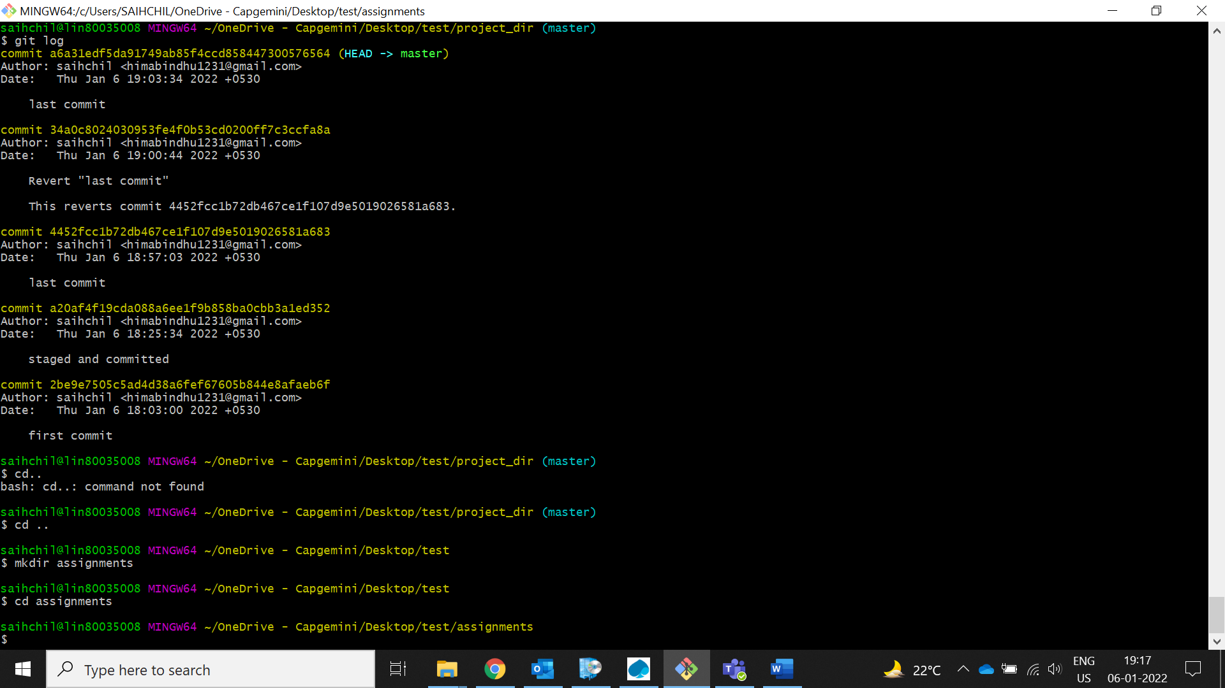

1. **Create a file README.txt inside ‘Assignments’ & write few lines about the contents of ‘Assignments’ folder.**

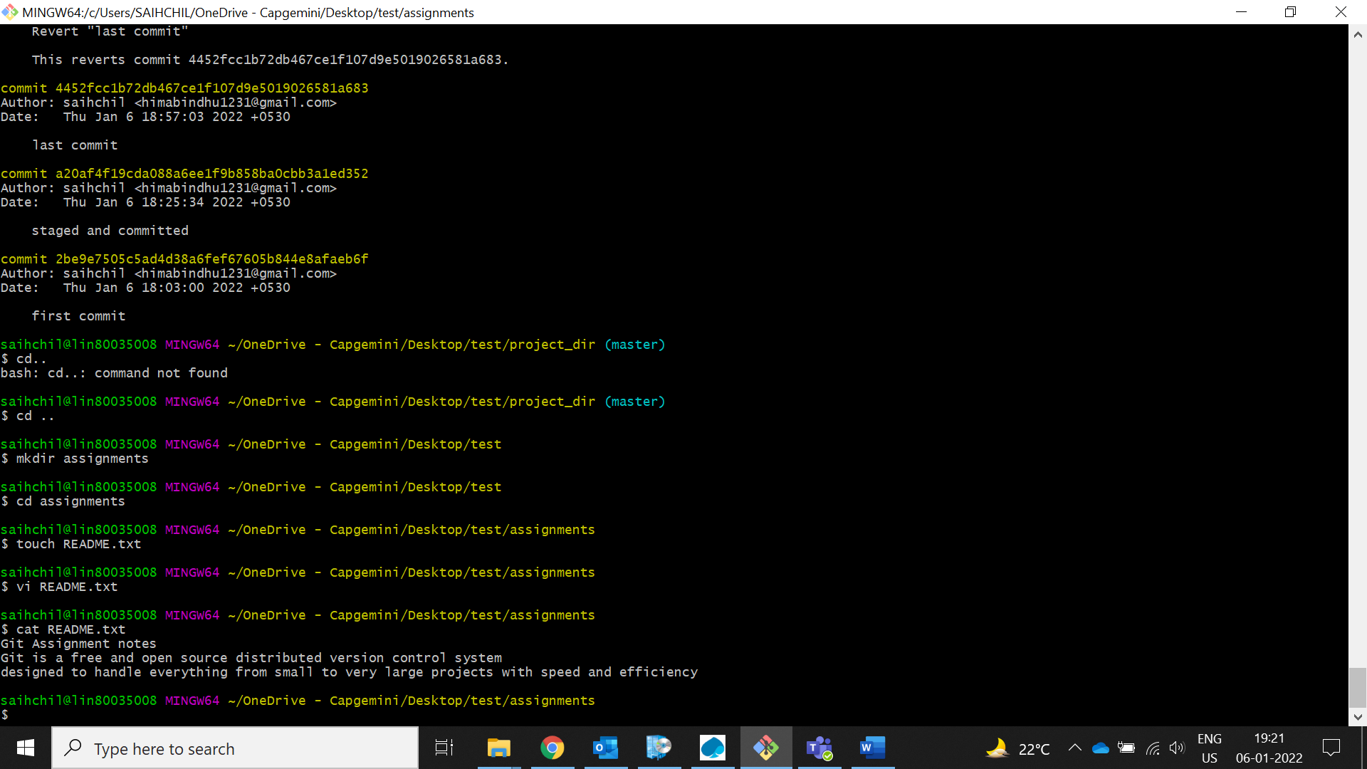

1. **Commit README.txt file.**

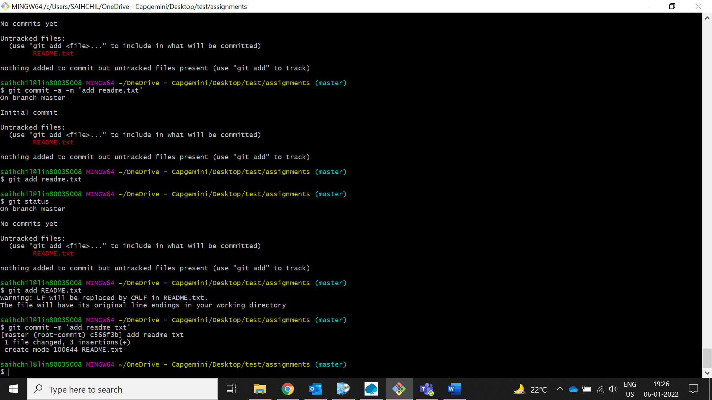

1. **Now create a new branch ‘html-assignments’.**

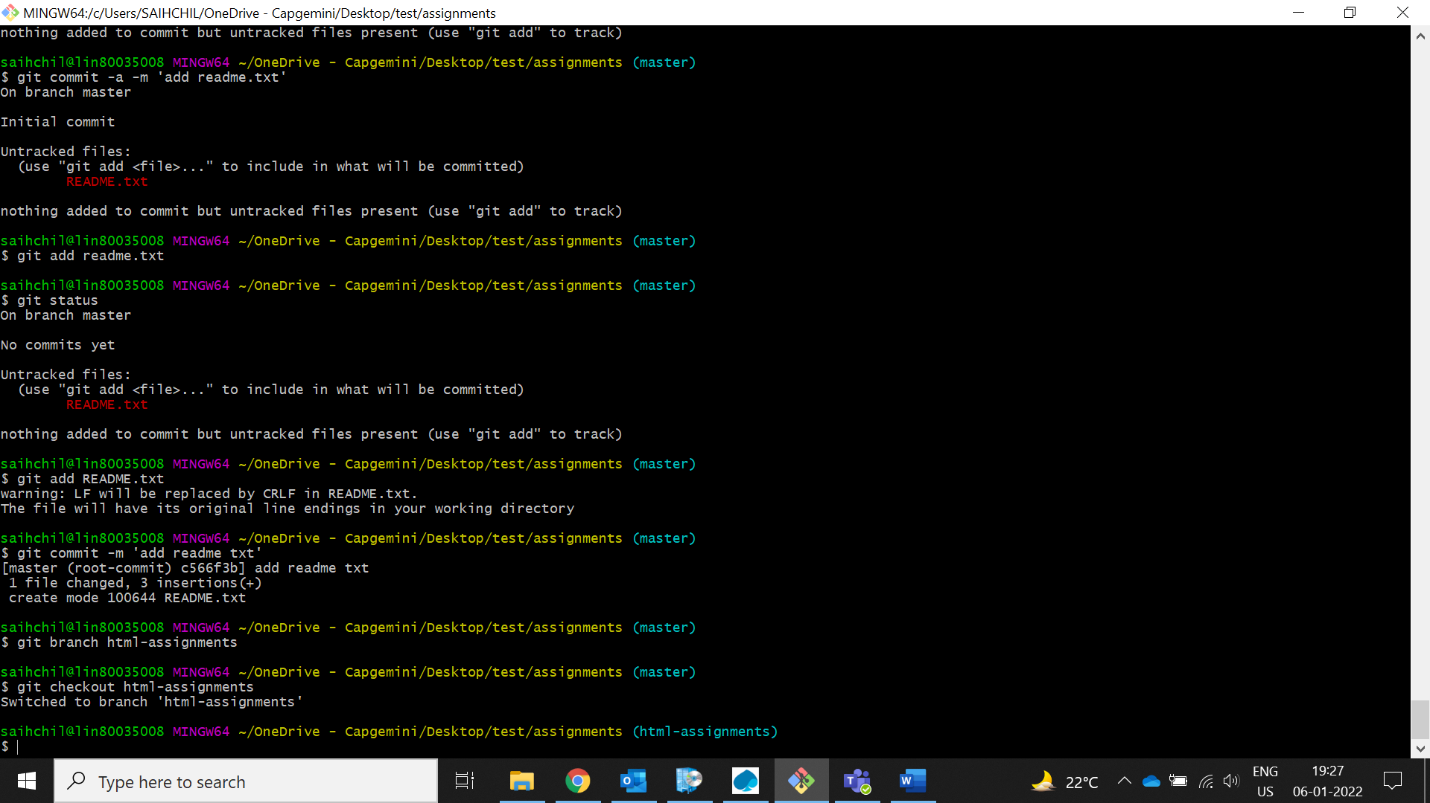

1. **Switch to ‘html-assignments’ branch.**



1. **Copy all HTML assignments inside ‘Assignments’ folder.**

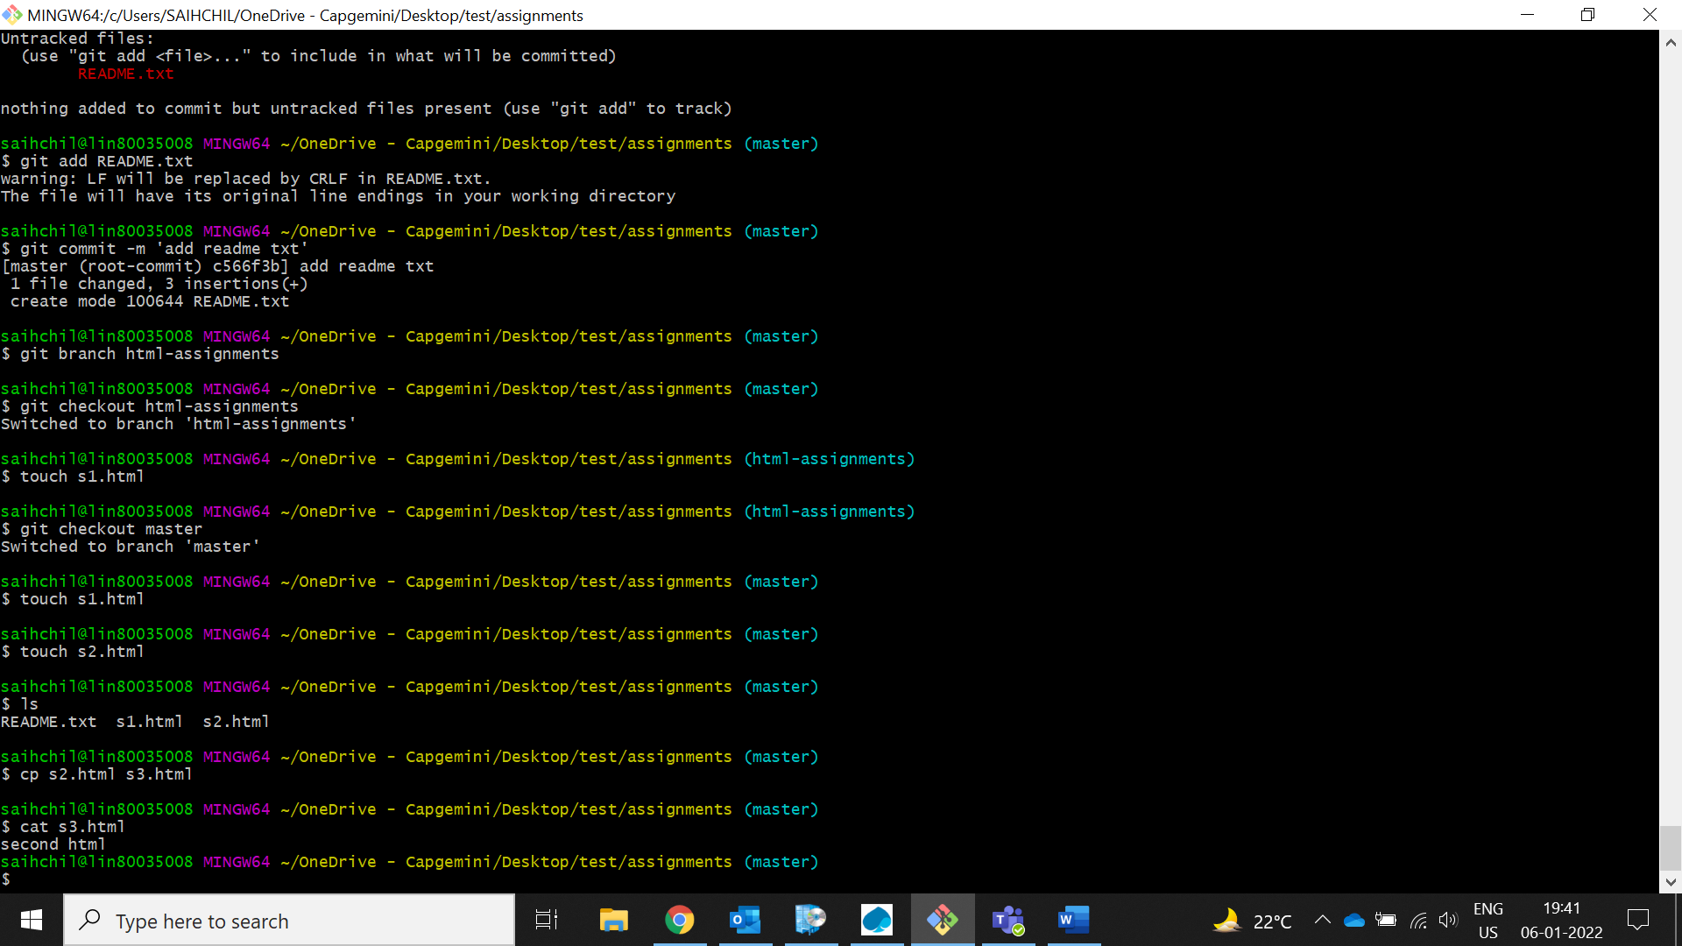

1. **Commit HTML assignments into ‘html-assignments’ branch.**

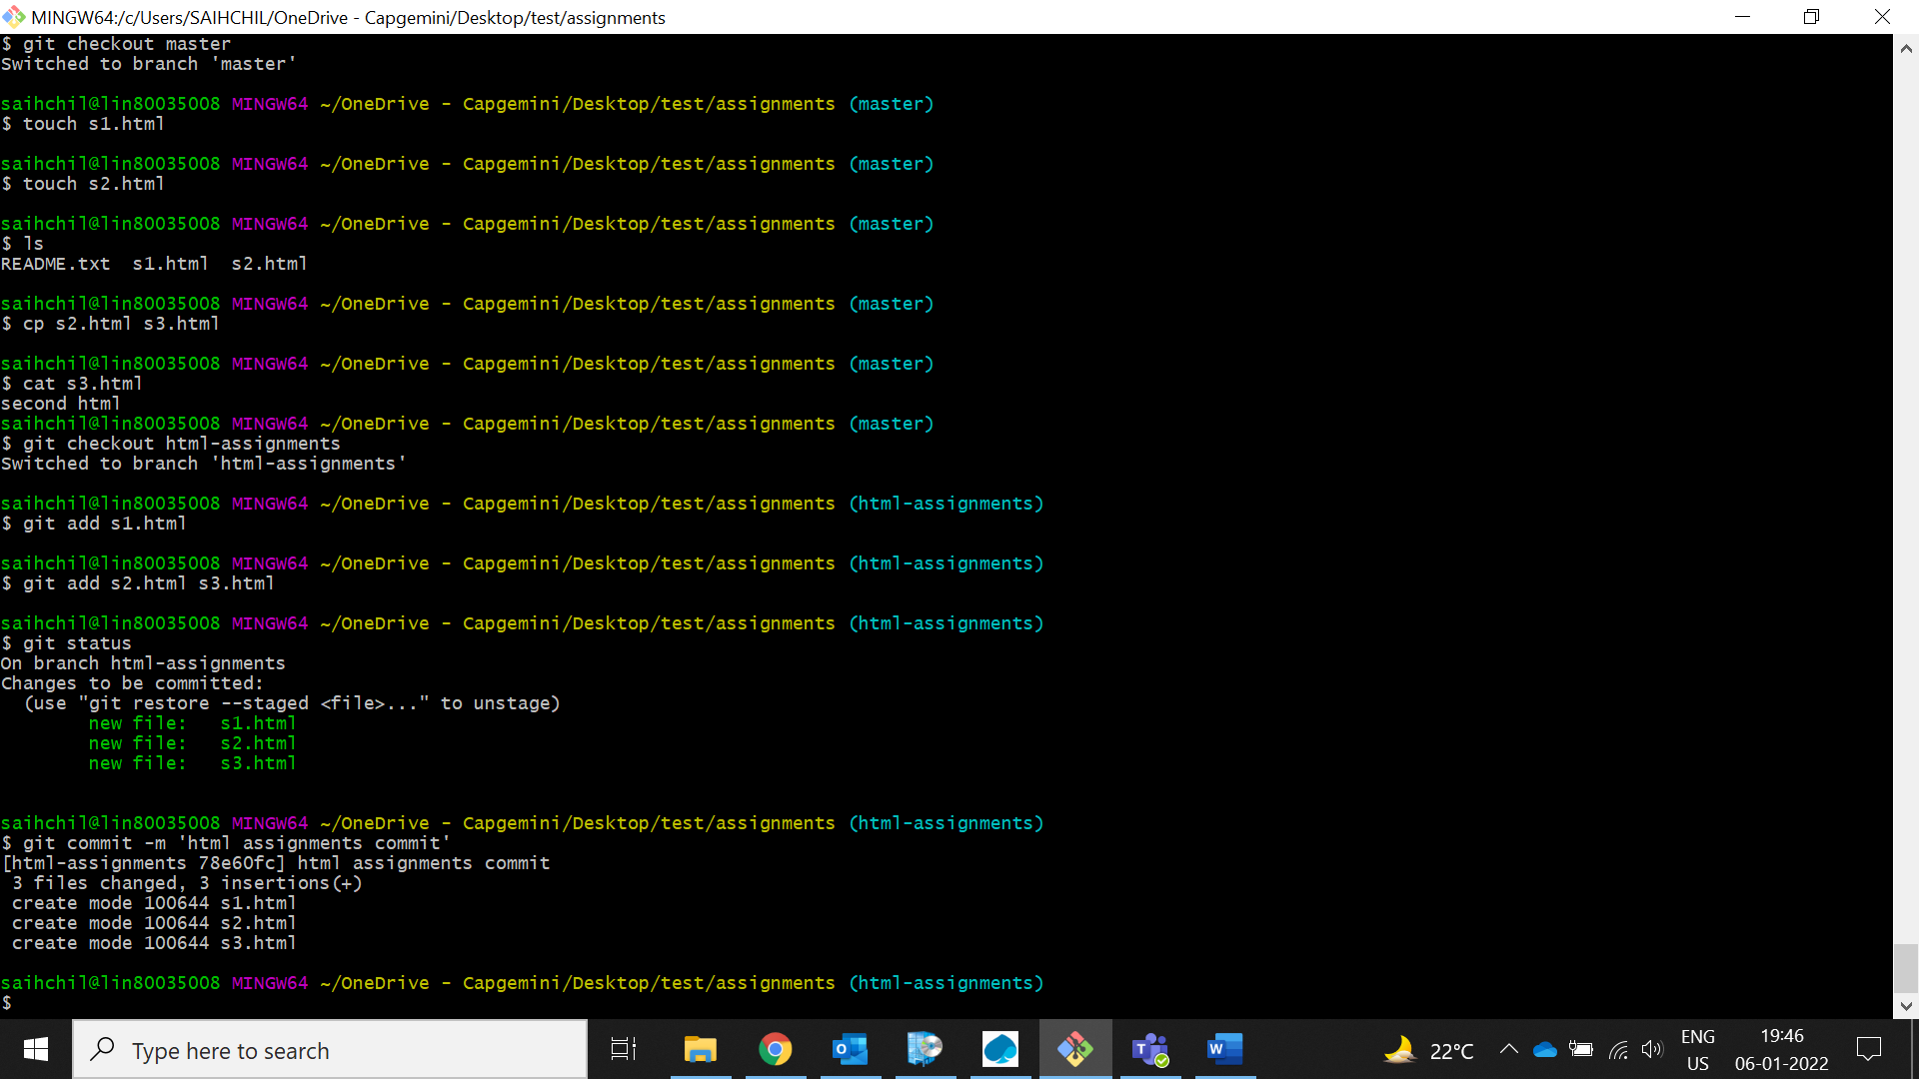

1. **Make minor changes into few files belonging to ‘html-assignments’ branch.**

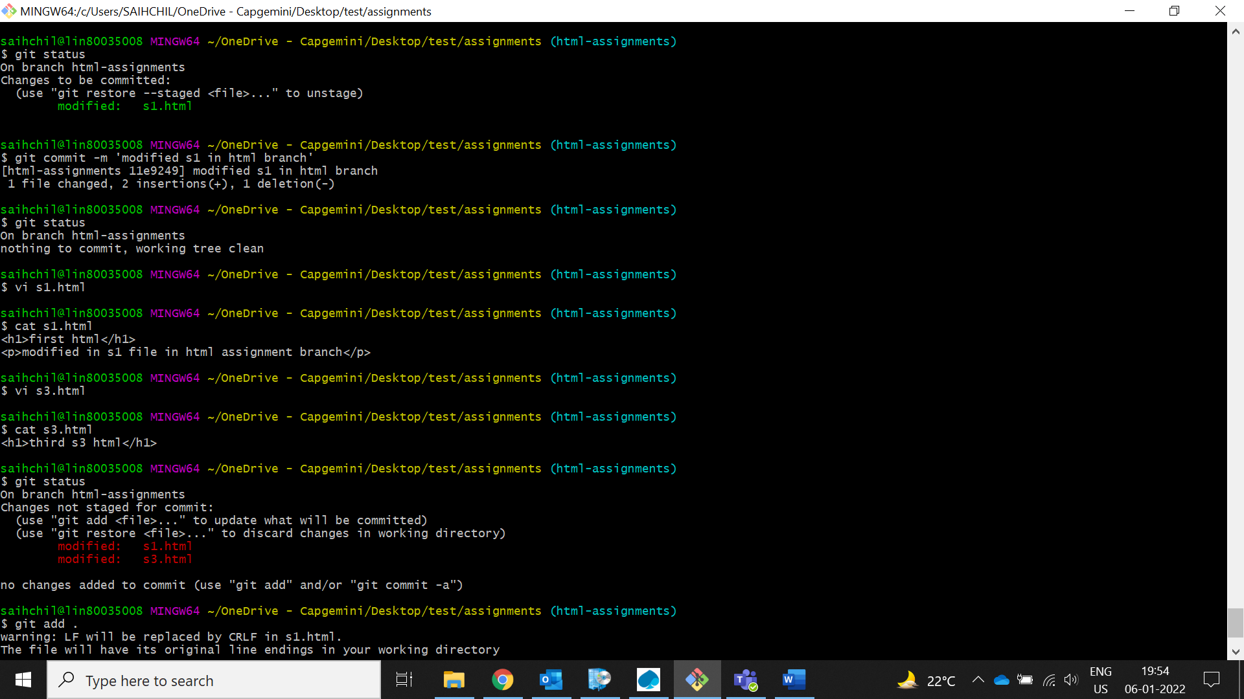

1. **Commit those changed files.**

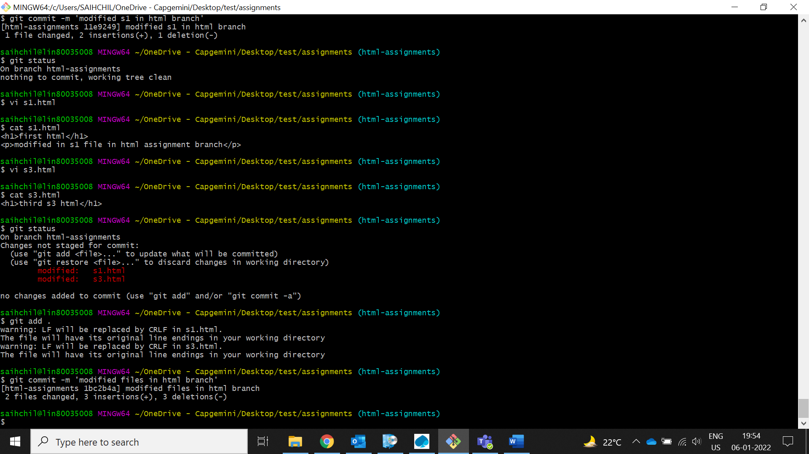

1. **Switch to master branch.**

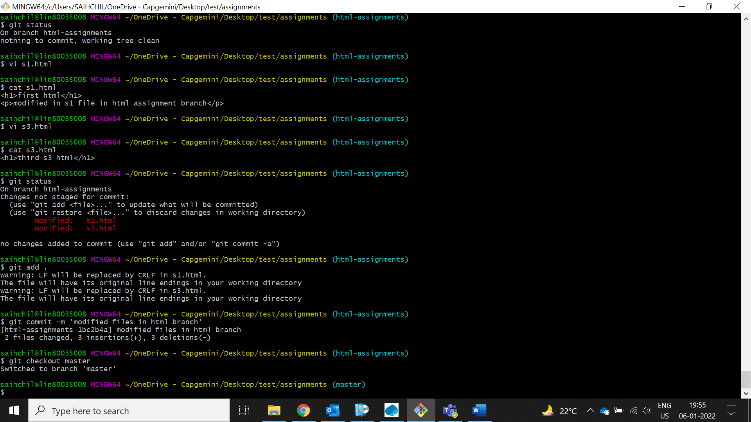

1. **Make minor changes into README.txt file & commit those changes into master.**

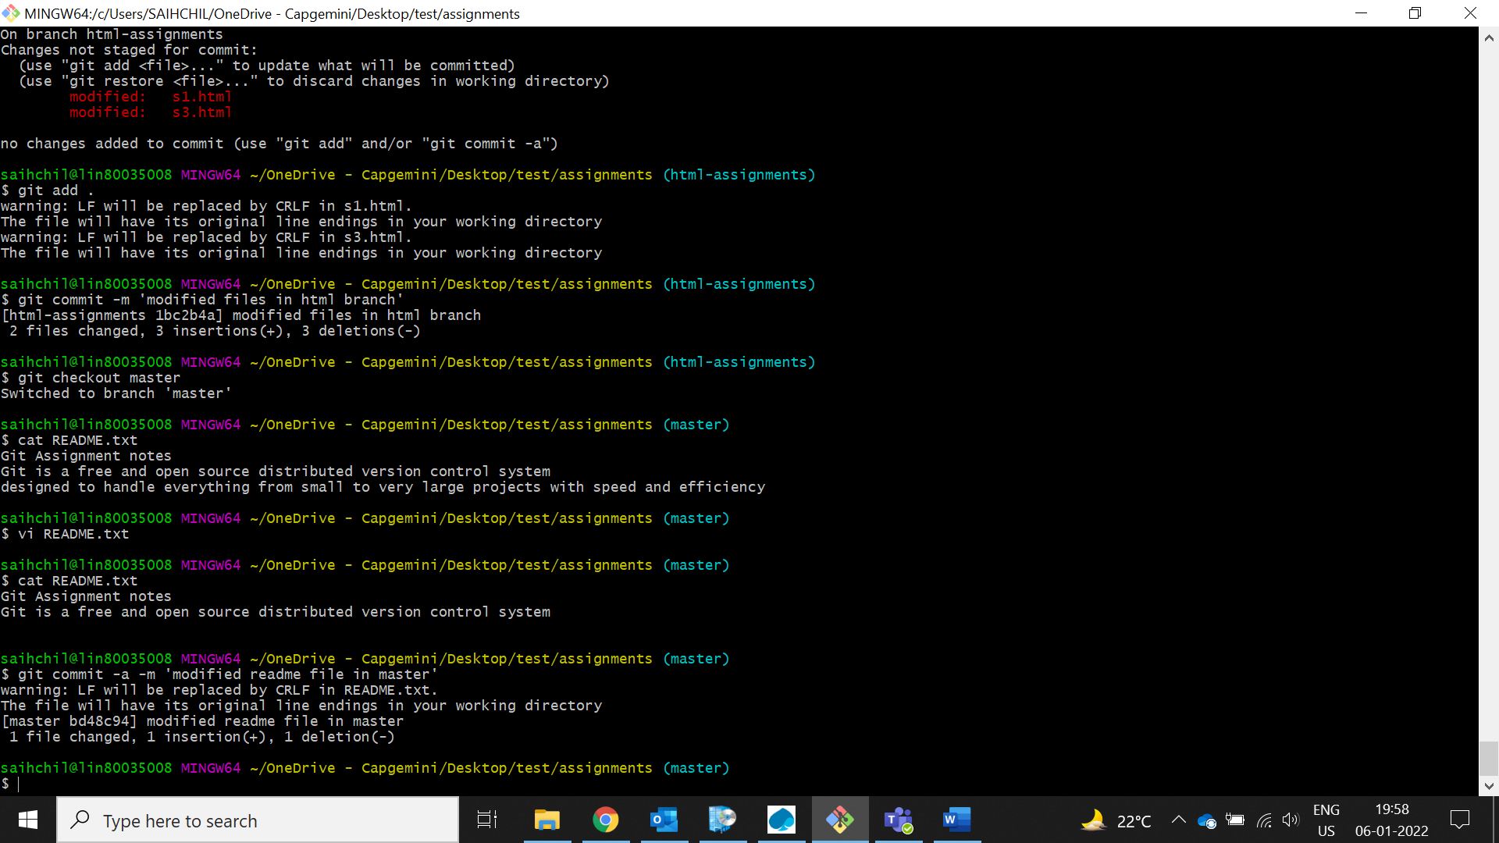

1. **Again switch to ‘html-assignments’ branch.**

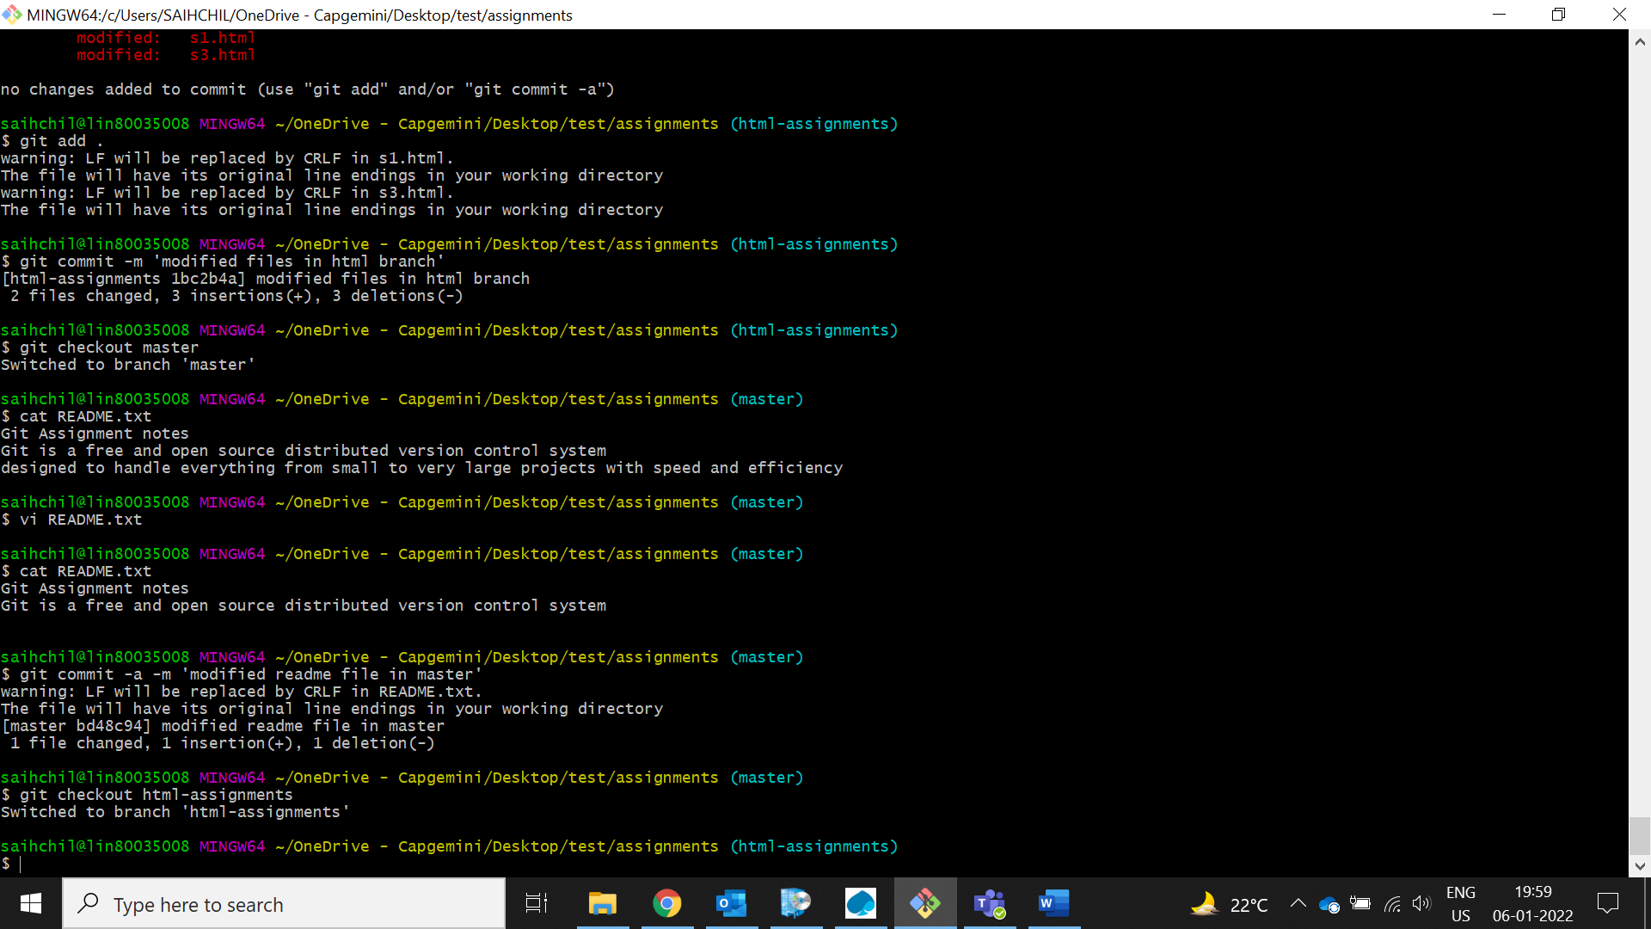

1. **Make minor changes into few files belonging to ‘html-assignments’ branch.**

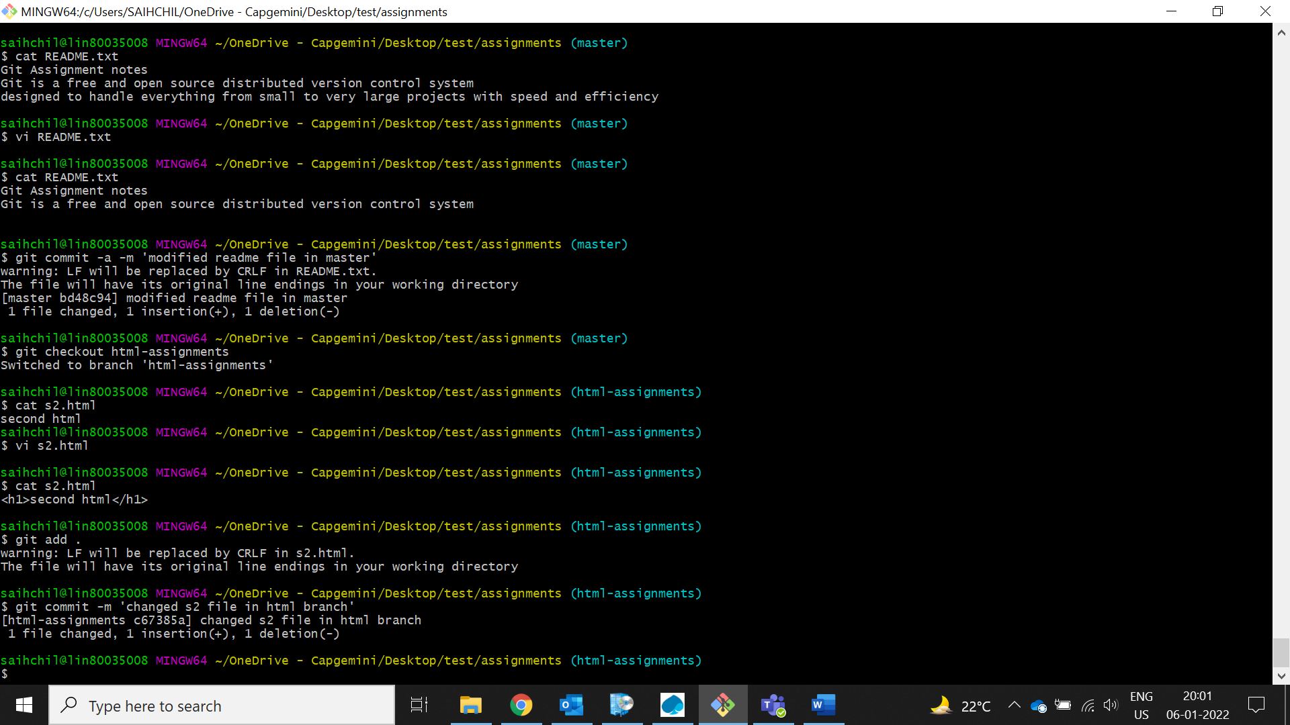

1. **Commit those changes.**



1. **Switch to master.**

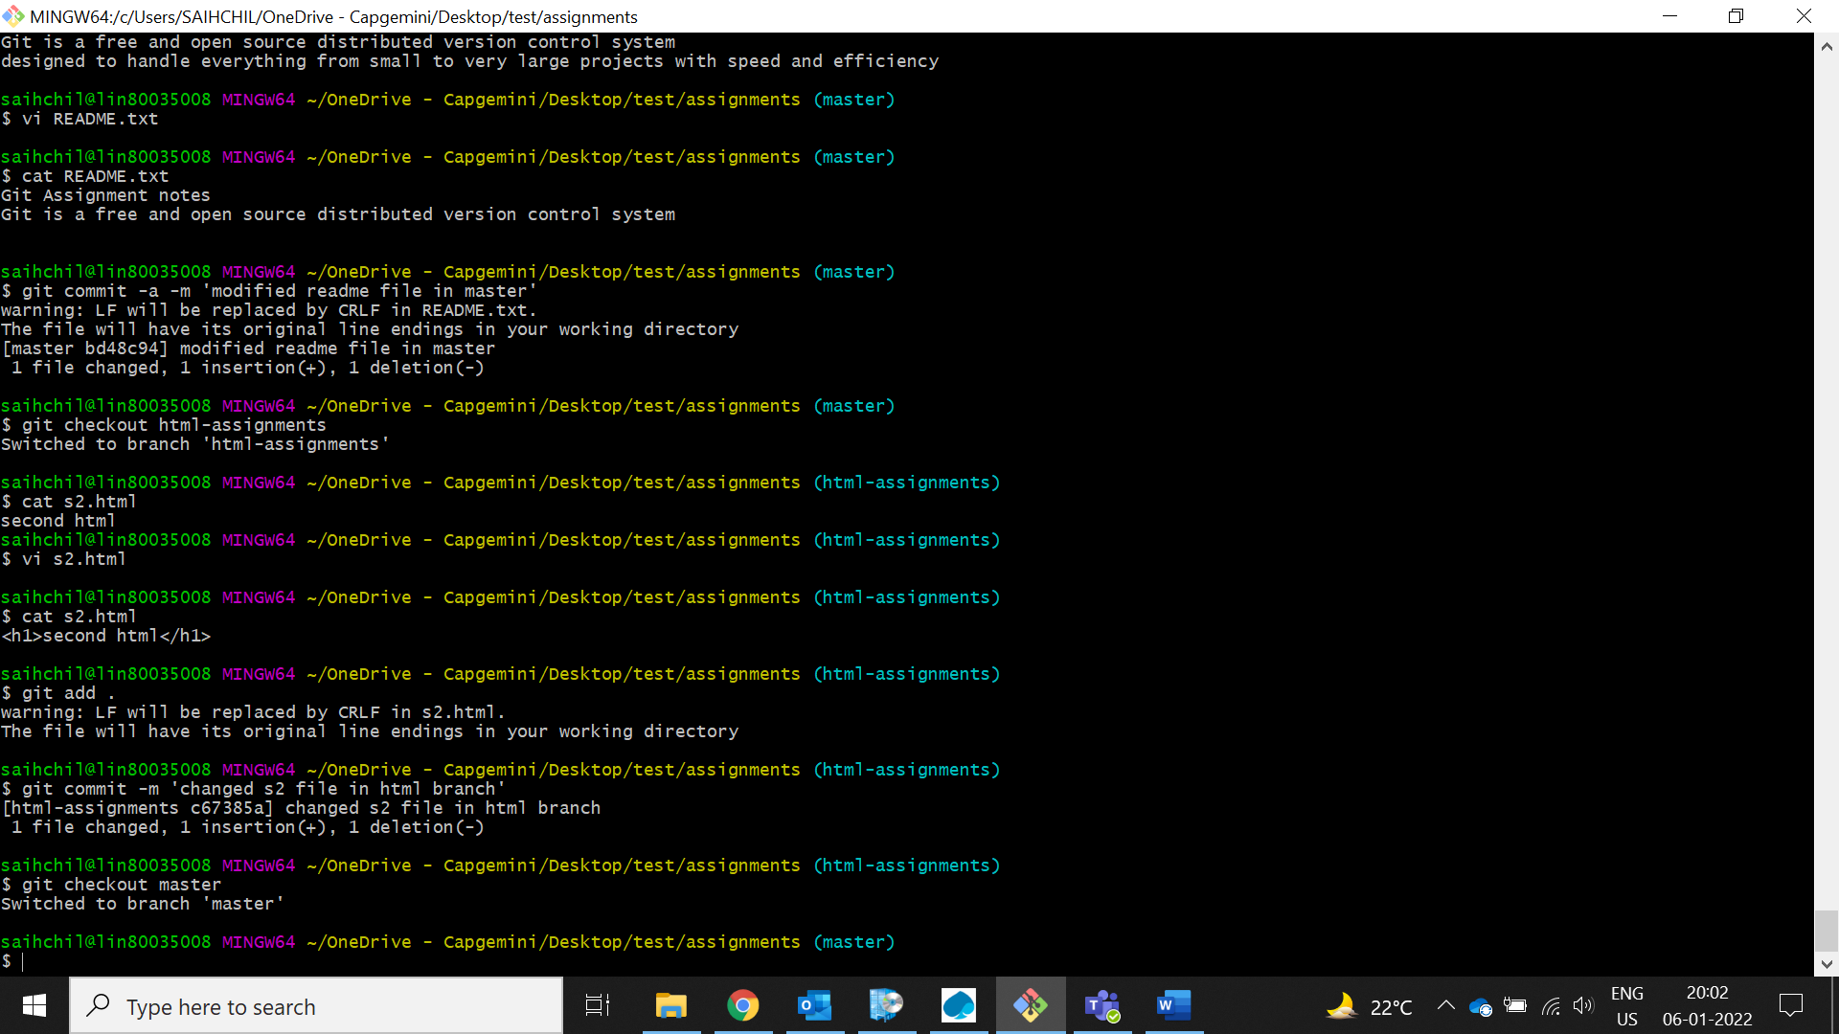

1. **Merge ‘html-assignments’ branch into master. Confirm all html assignments are shown in master.**

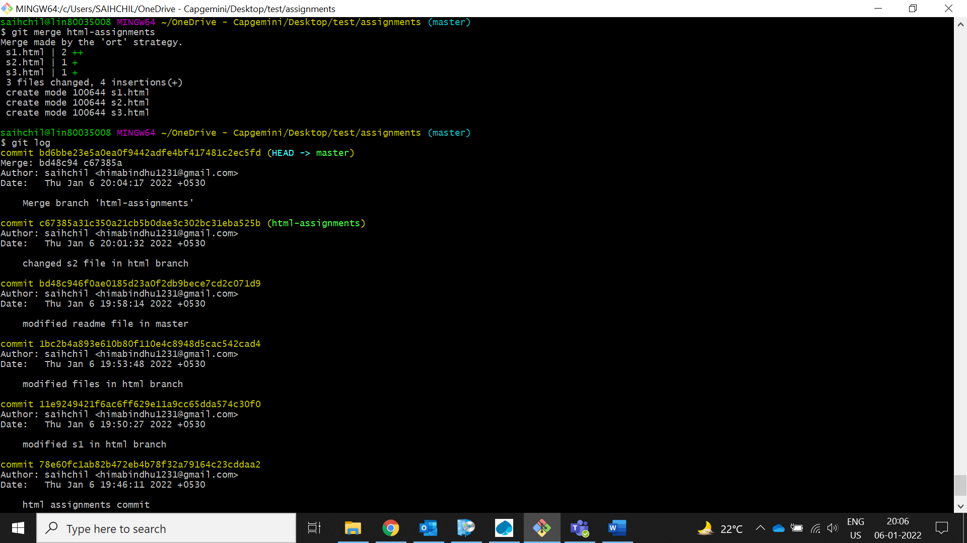

1. **Finally delete the ‘html-assignments’ branch.**

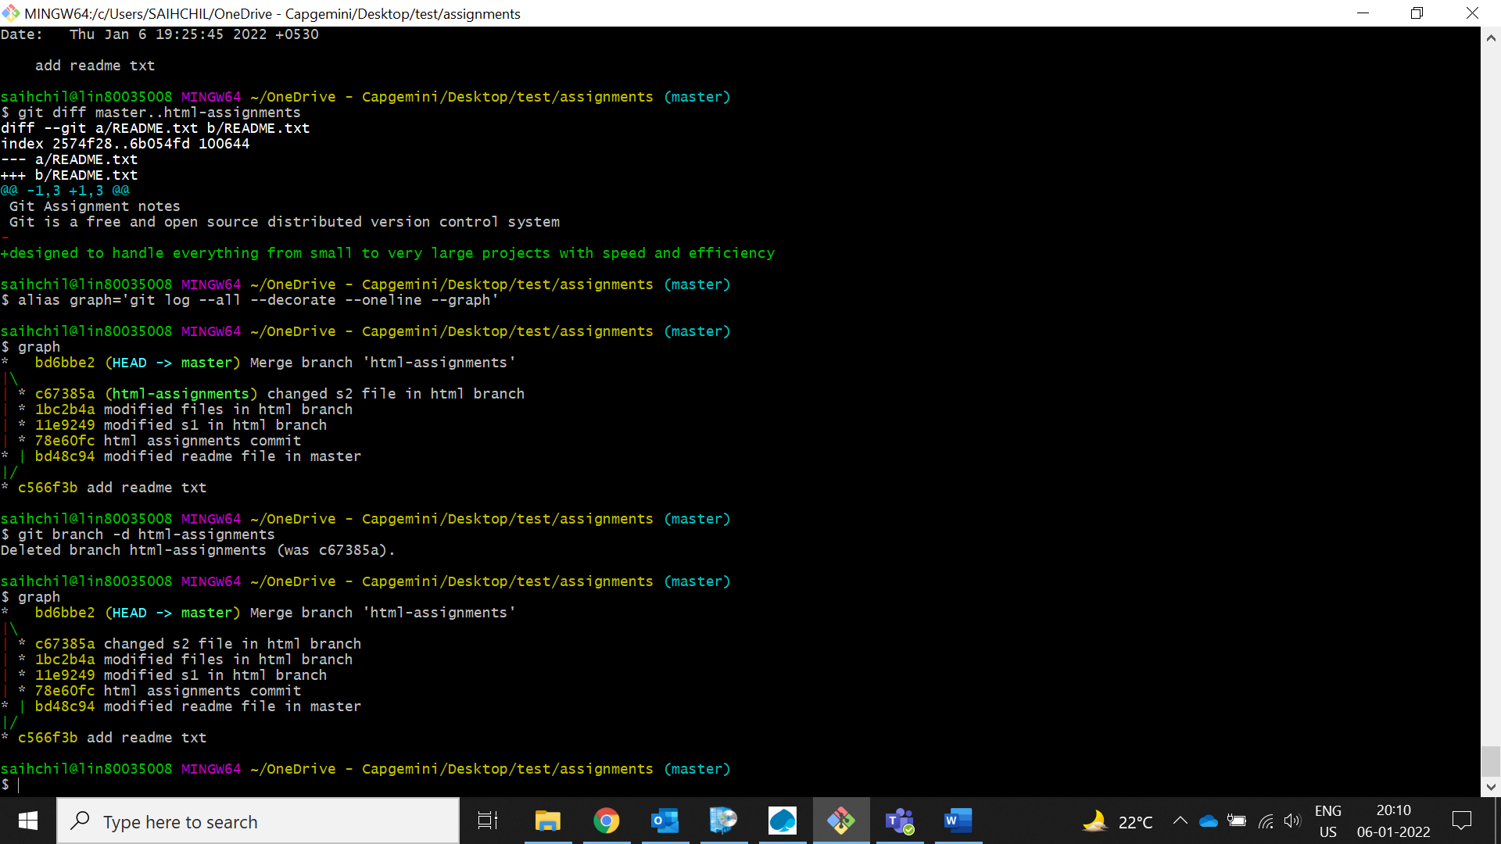

SECTION-2 - (CSS assignments) Steps to follow:

1. **Create a new branch ‘css-assignments’.**

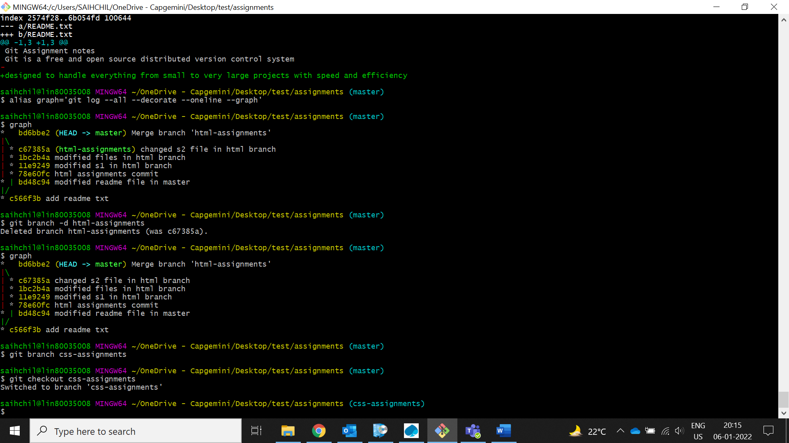

1. **Switch to ‘css-assignments’ branch.**



1. **Copy all CSS assignments inside ‘Assignments’ folder.**

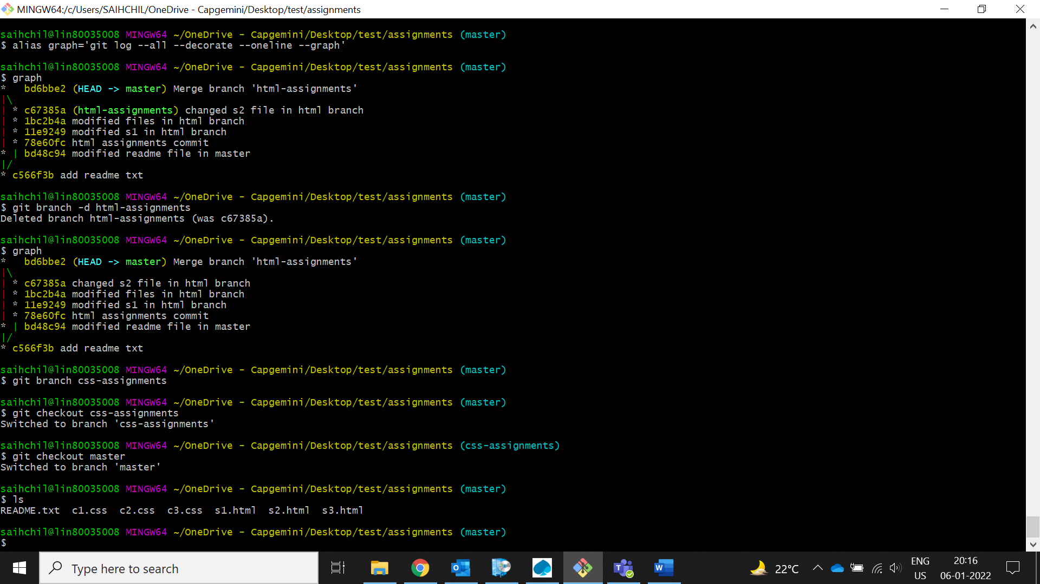

1. **Commit CSS assignments into ‘css-assignments’ branch.**

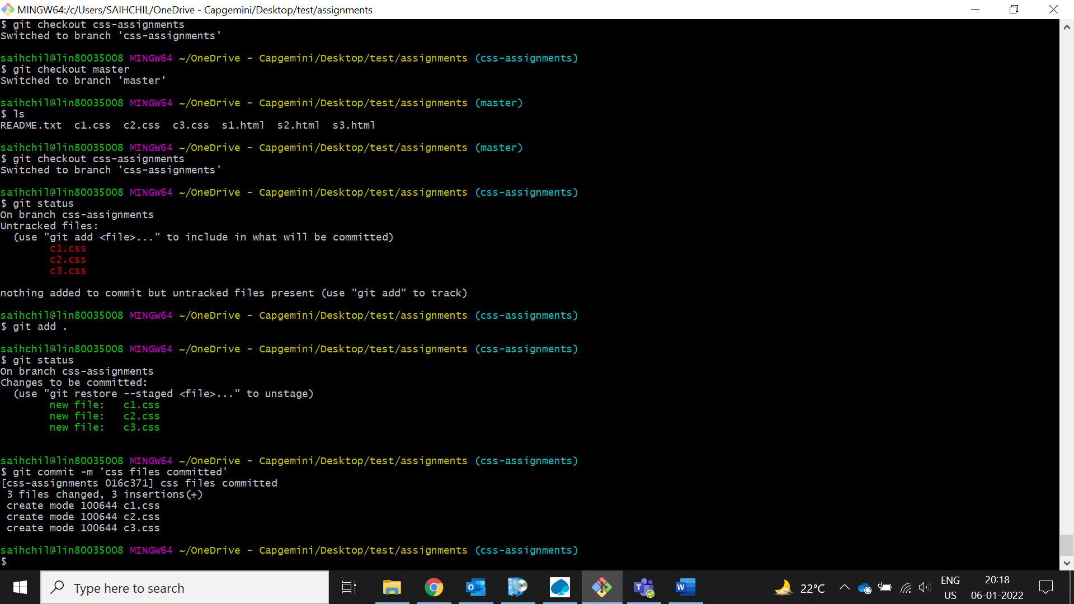

1. **Make minor changes into README.txt file on line 1 belonging to ‘css-assignments’ branch.**

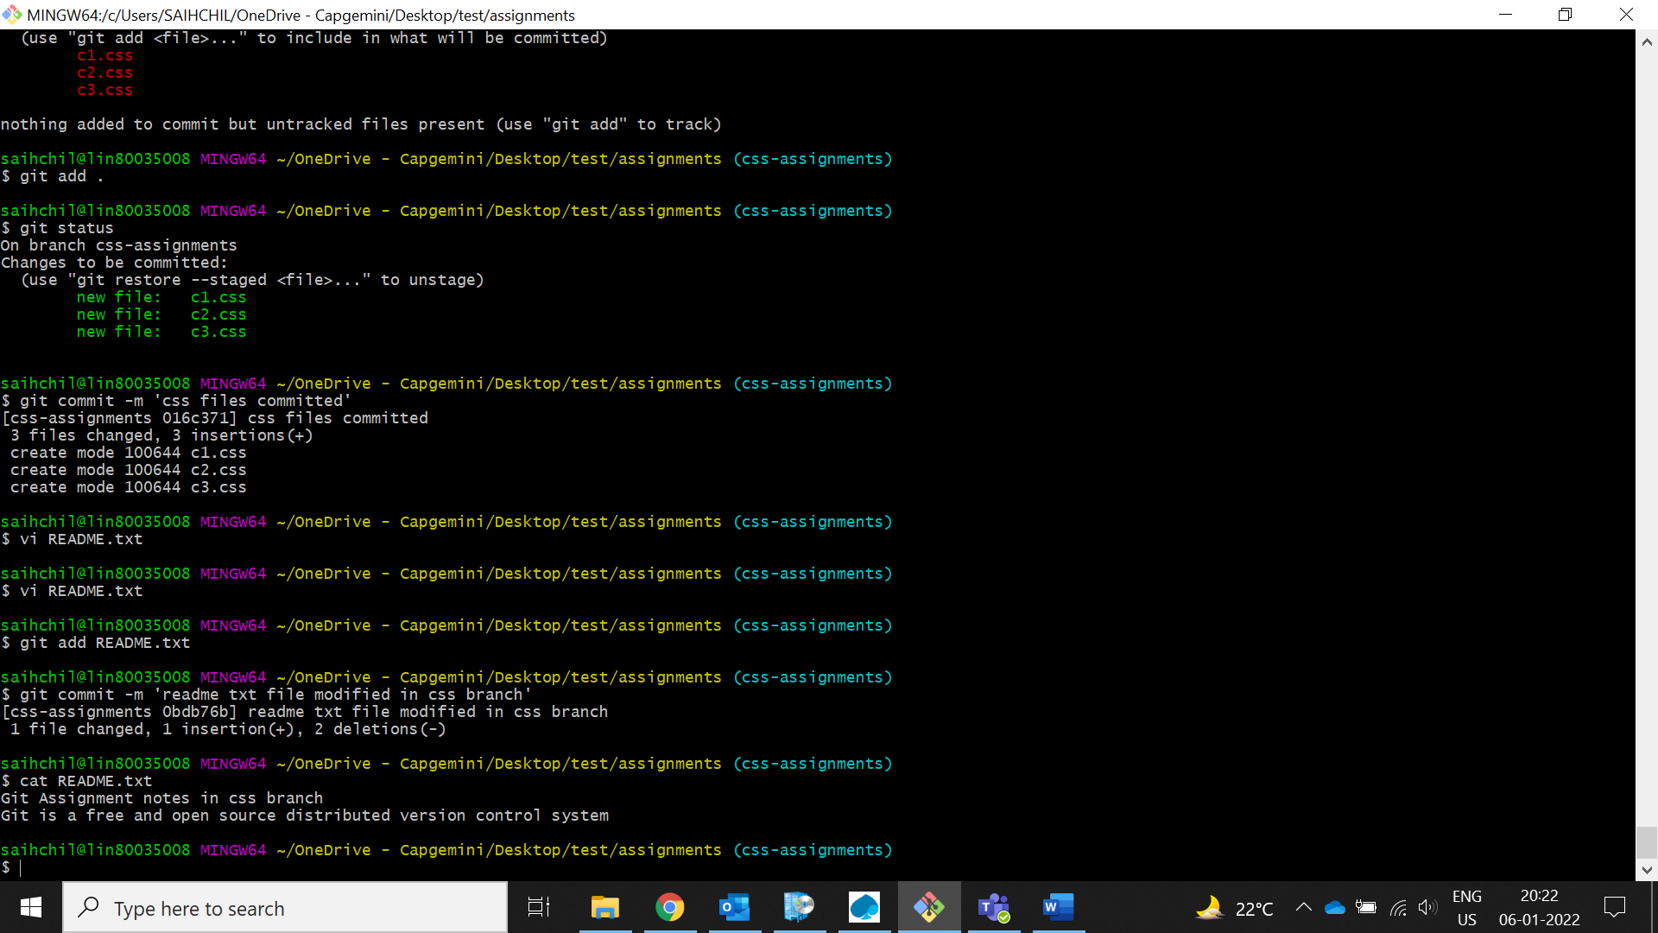

1. **Commit those changed files.**

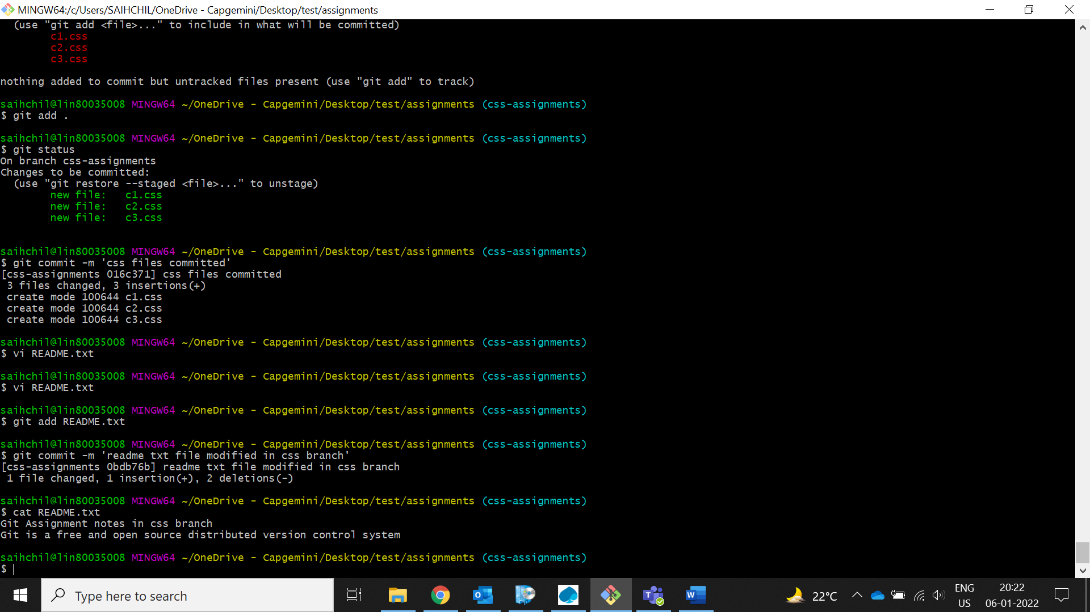

1. **Switch to master branch.**

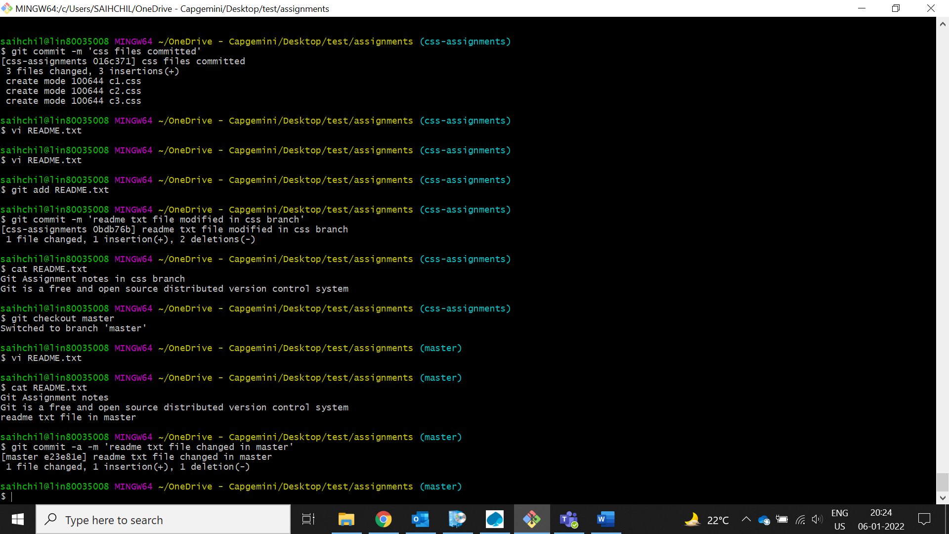

1. **Make minor changes into README.txt file on line 3 & commit those changes into master.**



1. **Again switch to ‘css-assignments’ branch.**

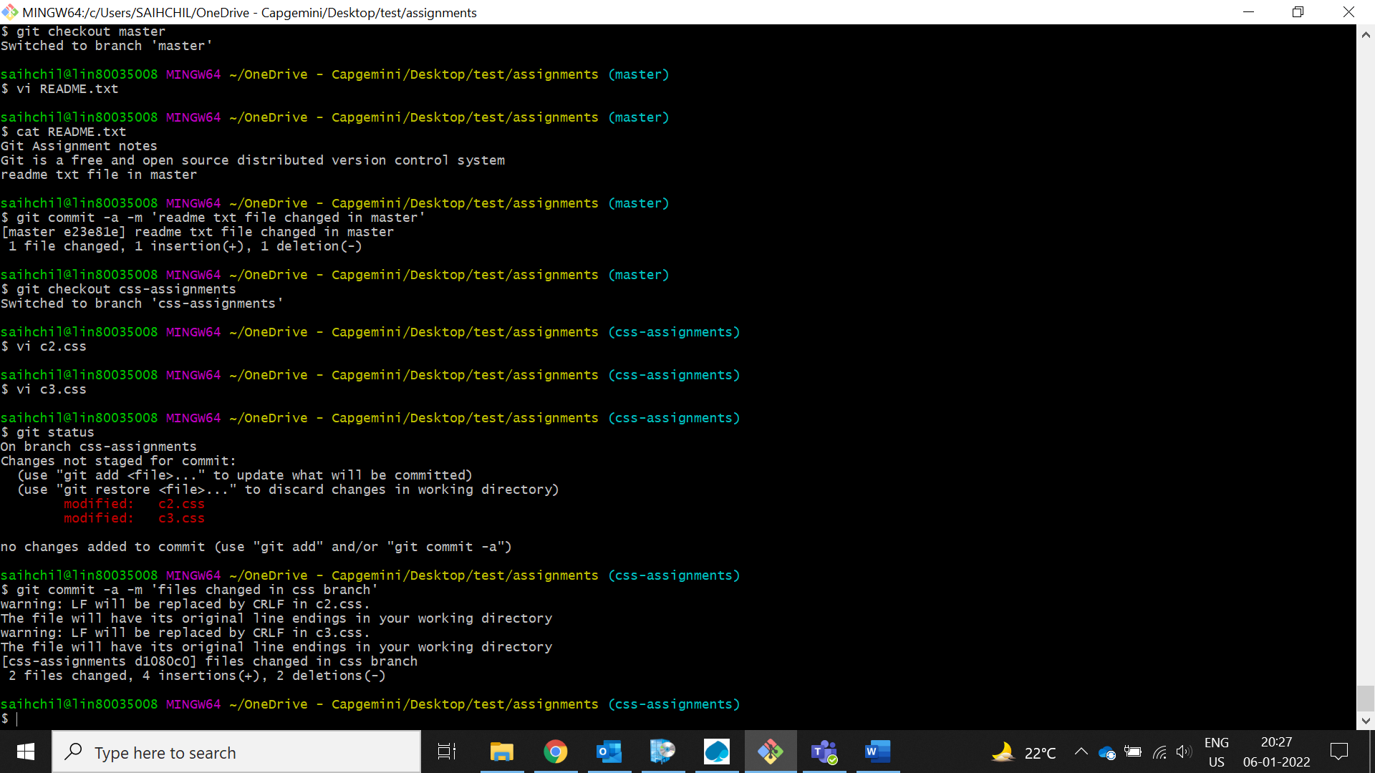

1. **Make minor changes into few files belonging to ‘css-assignments’ branch.**



1. **Commit those changes.**



1. **Switch to master.**

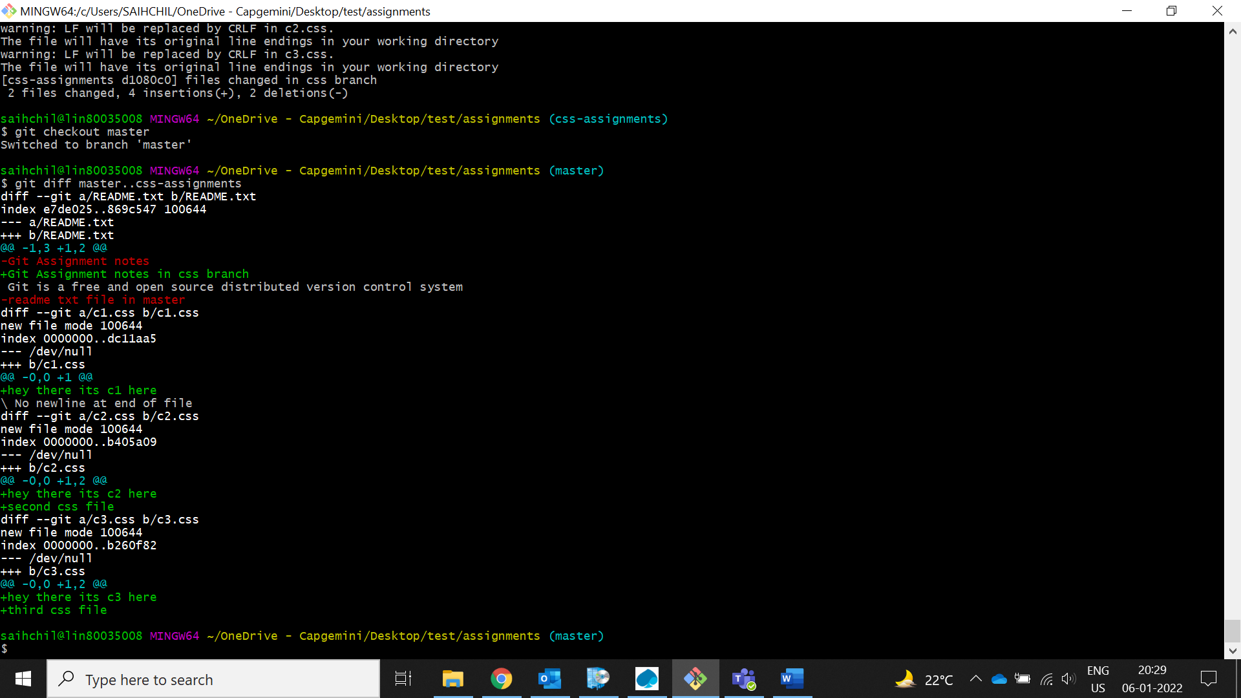

1. **Merge ‘css-assignments’ branch into master. Confirm all css assignments are shown in master.**

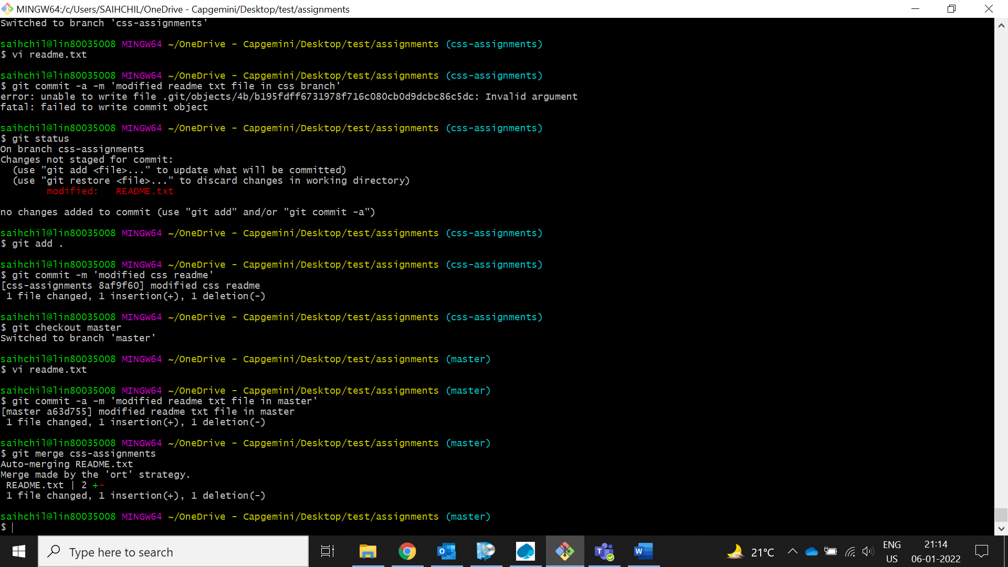

1. **Finally delete the ‘css-assignments’ branch.**

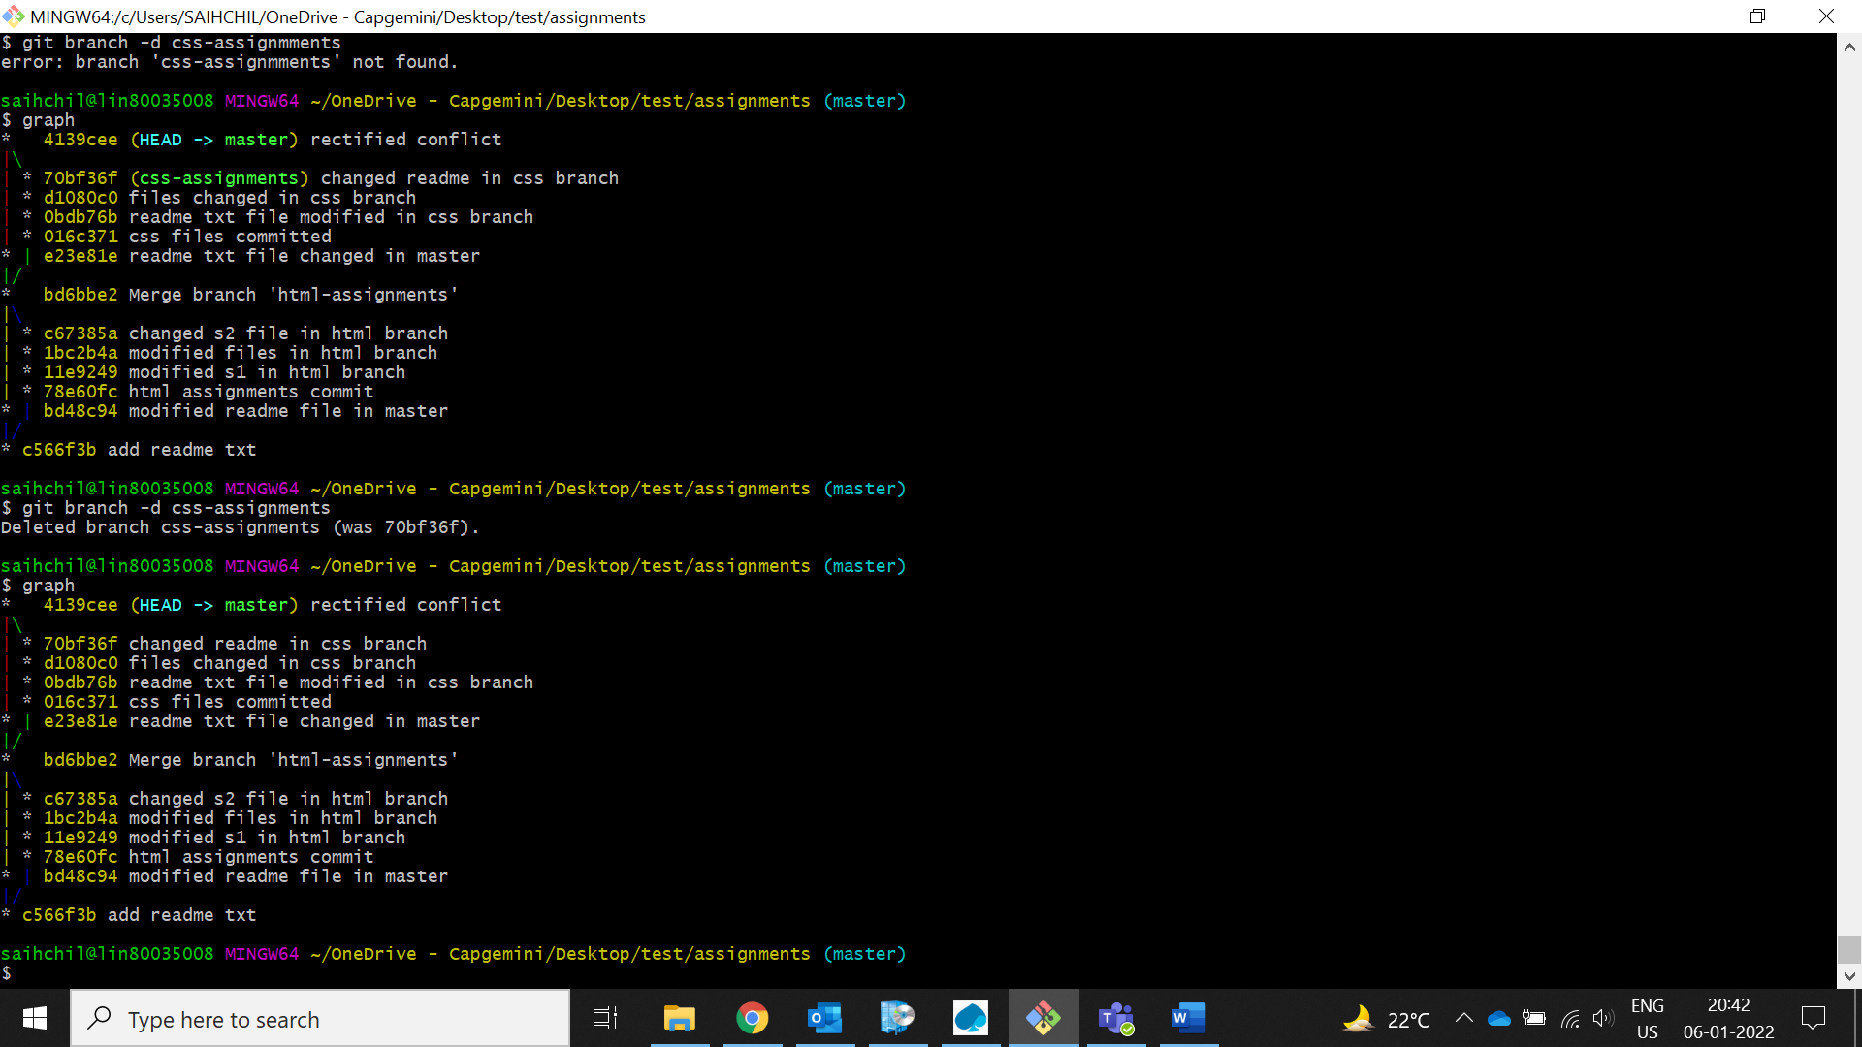

SECTION-3 - (JavaScript assignments) Steps to follow:

1. **Create a new branch ‘js-assignments’.**

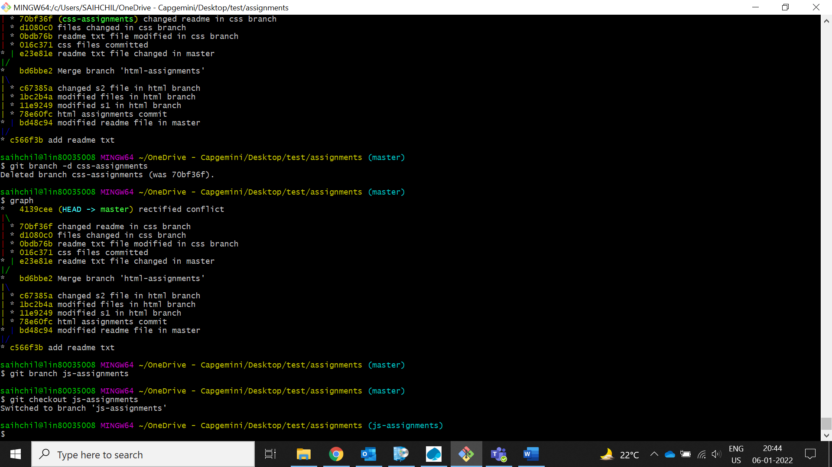

1. **Switch to ‘js-assignments’ branch.**



1. **Copy all JavaScript assignments inside ‘Assignments’ folder.**

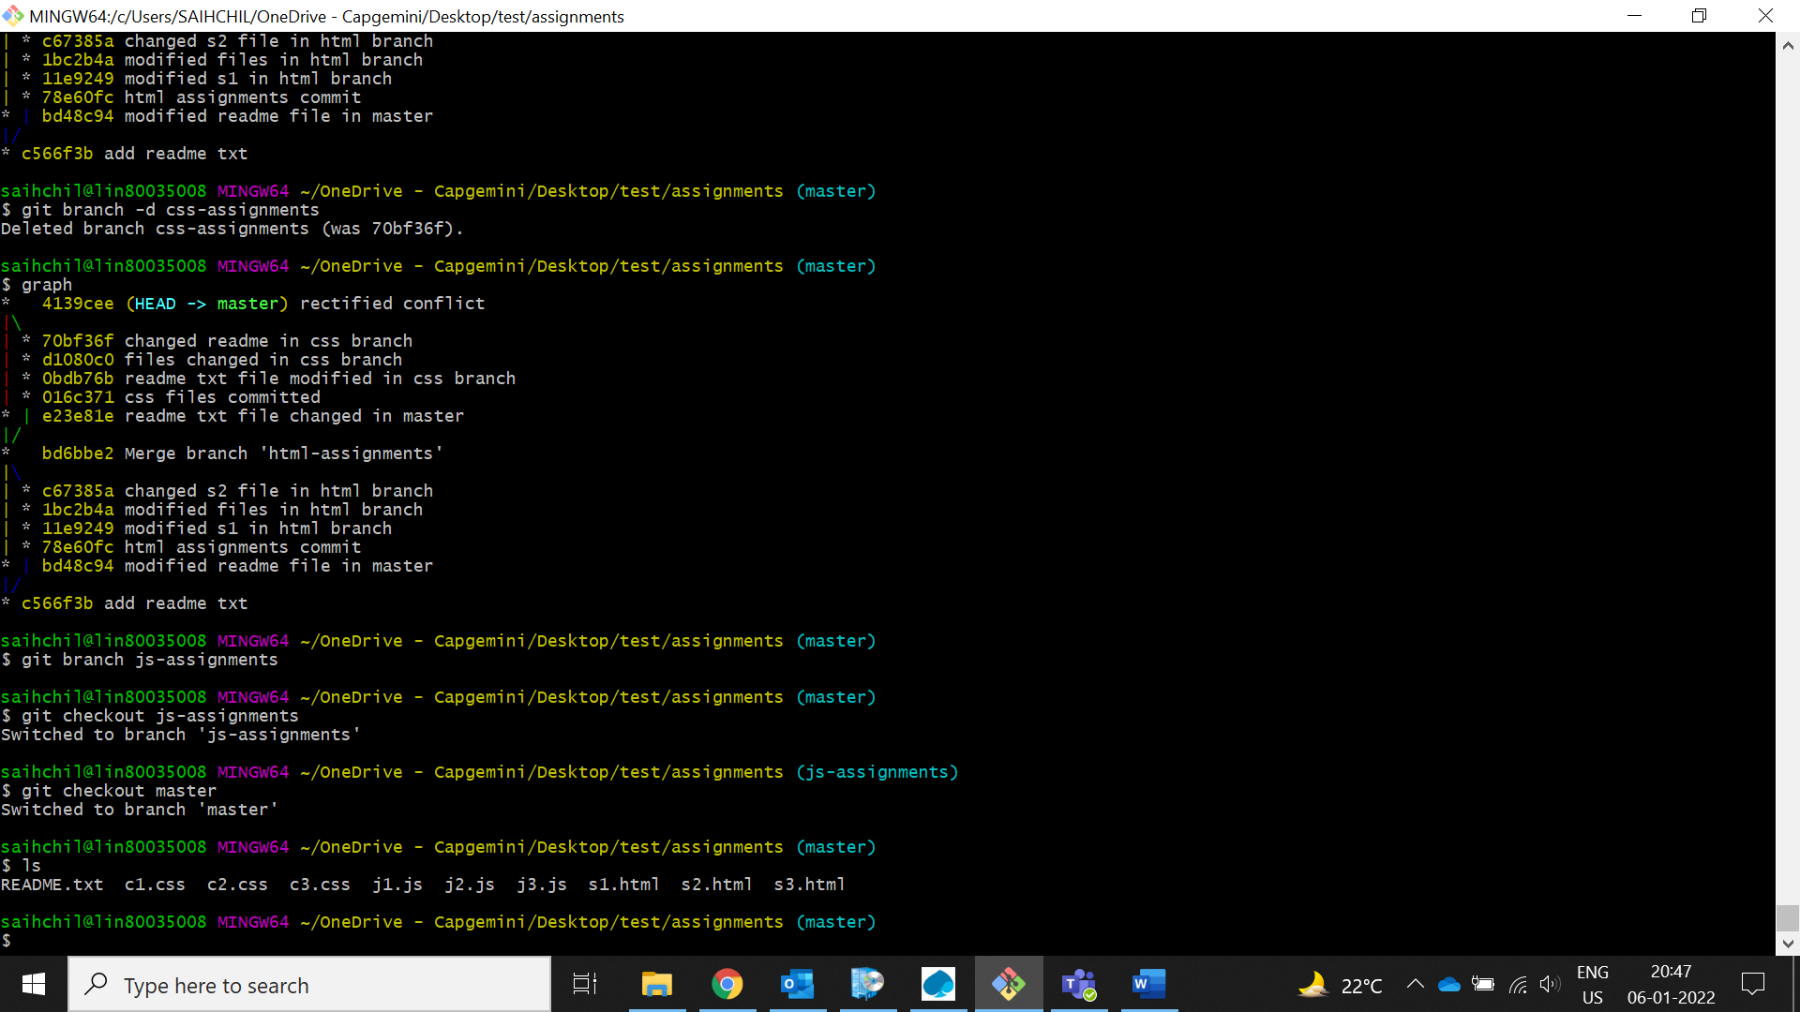

1. **Commit JavaScript assignments into ‘js-assignments’ branch.**

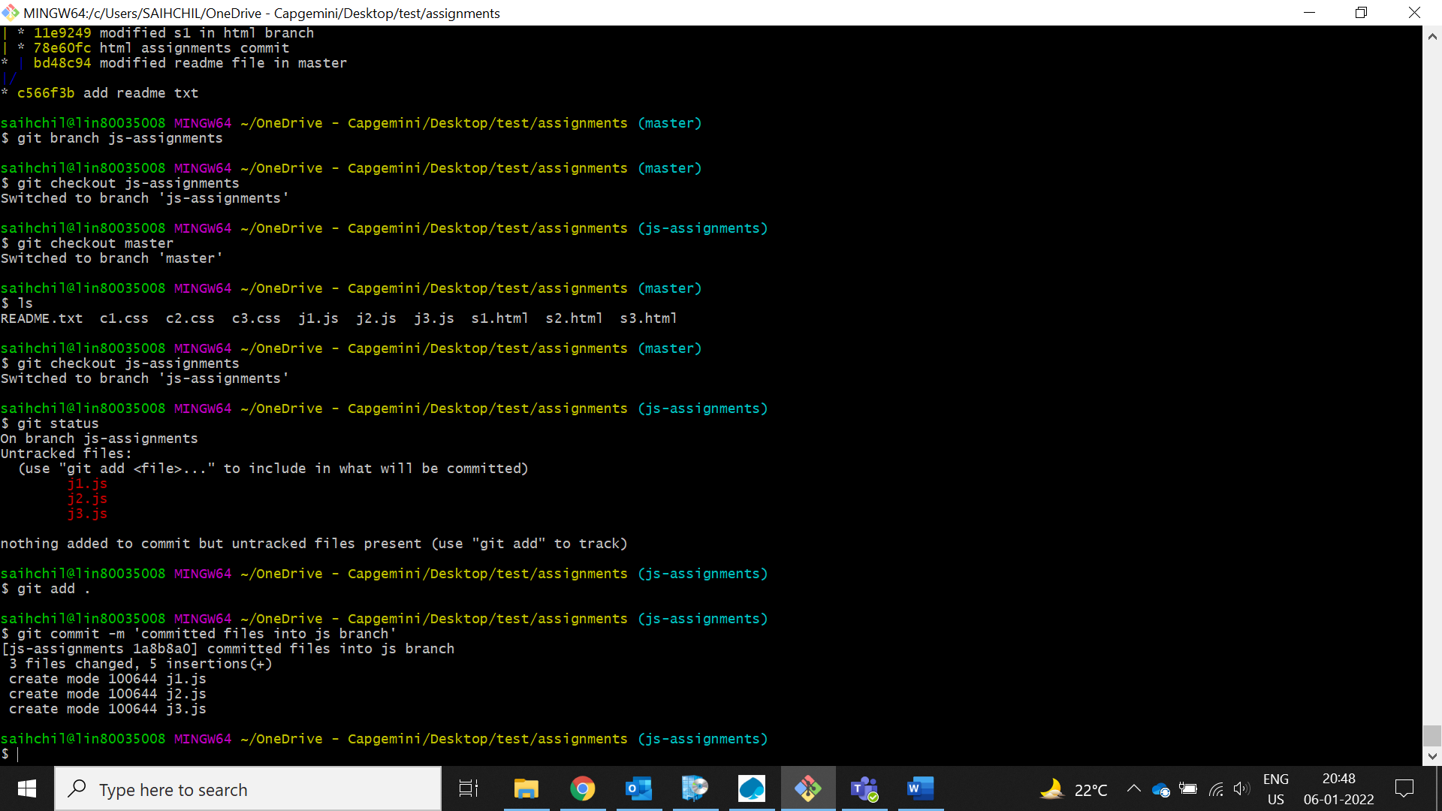

1. **Make minor changes into README.txt file on line 1 belonging to ‘js-assignments’ branch.**

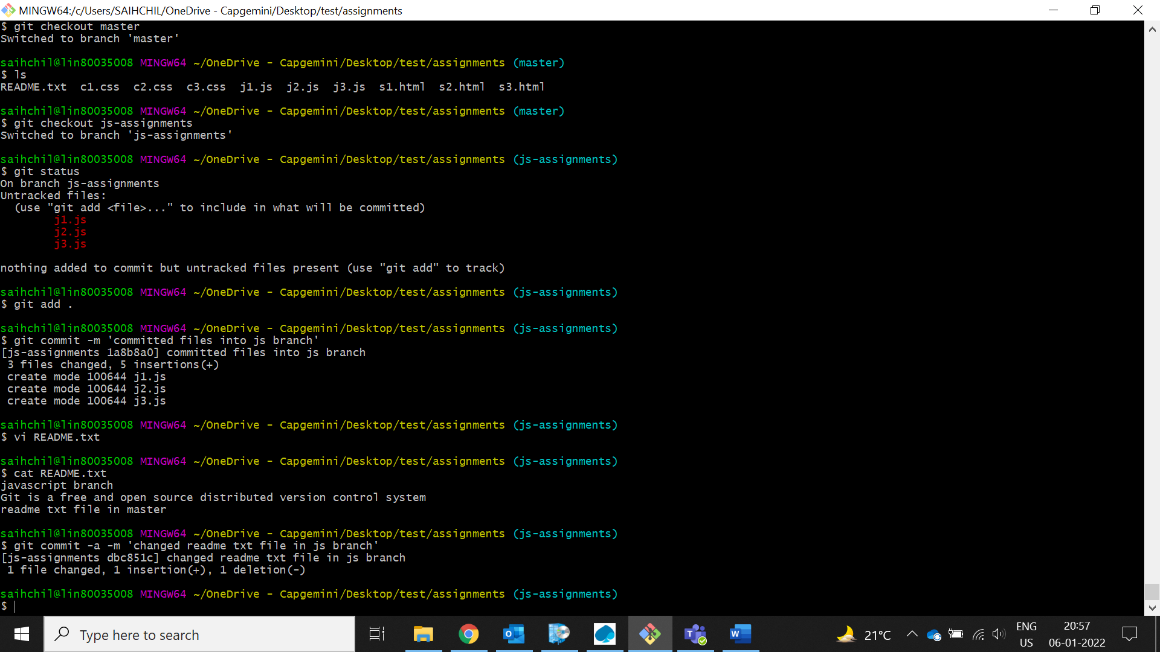

1. **Commit those changed files.**



1. **Switch to master branch.**

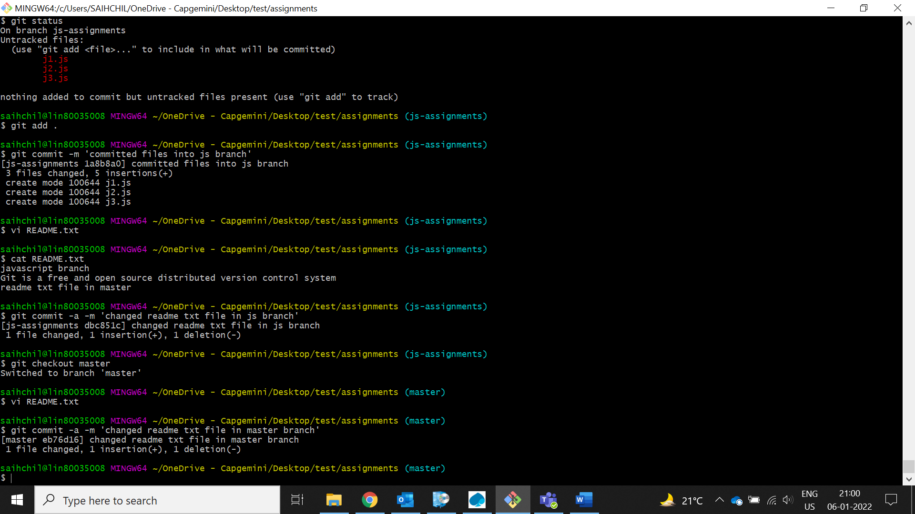

1. **Make minor changes into README.txt file on line 1 & commit those changes into master.**



1. **Again switch to ‘js-assignments’ branch.** 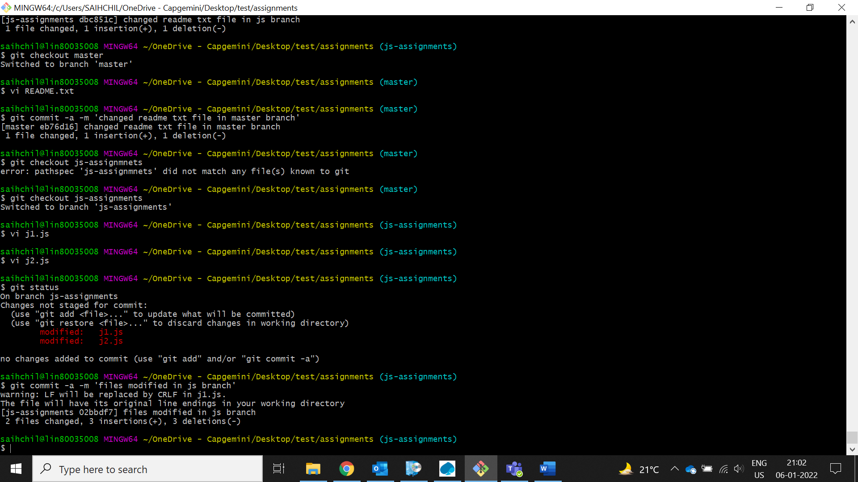
2. **Make minor changes into few files belonging to ‘js-assignments’ branch.**



1. **Commit those changes.**



1. **Switch to master.**

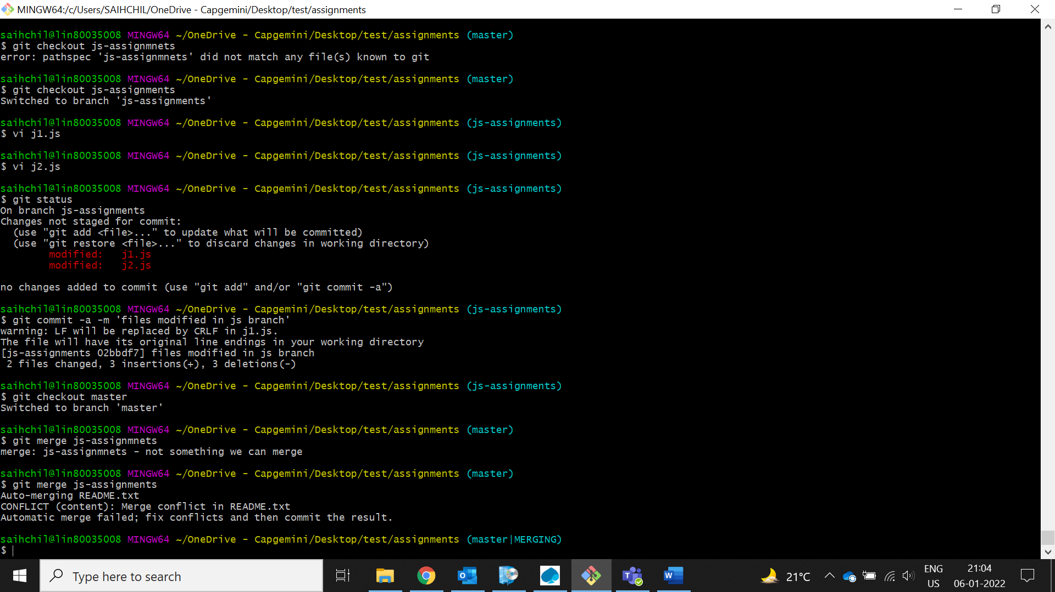

1. **Merge ‘js-assignments’ branch into master. Confirm all JavaScript assignments are shown in master.** 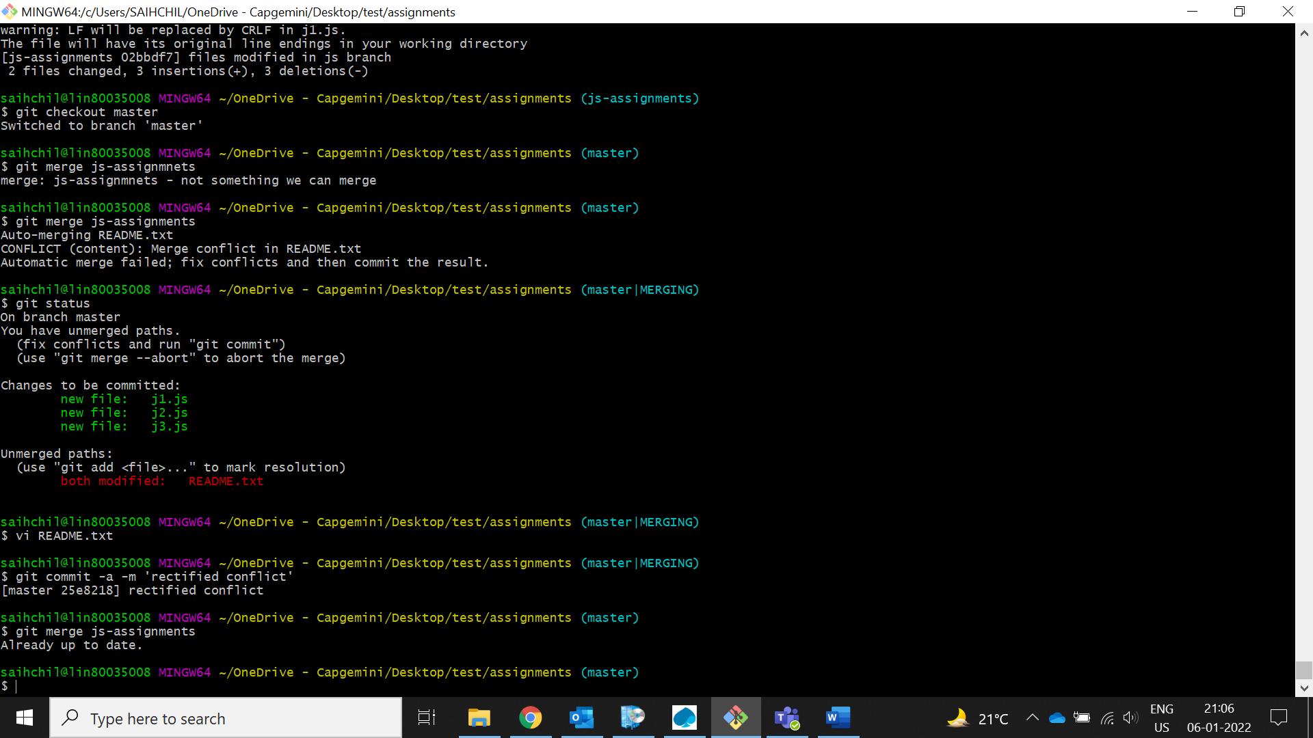
2. **Finally delete the ‘js-assignments’ branch.**

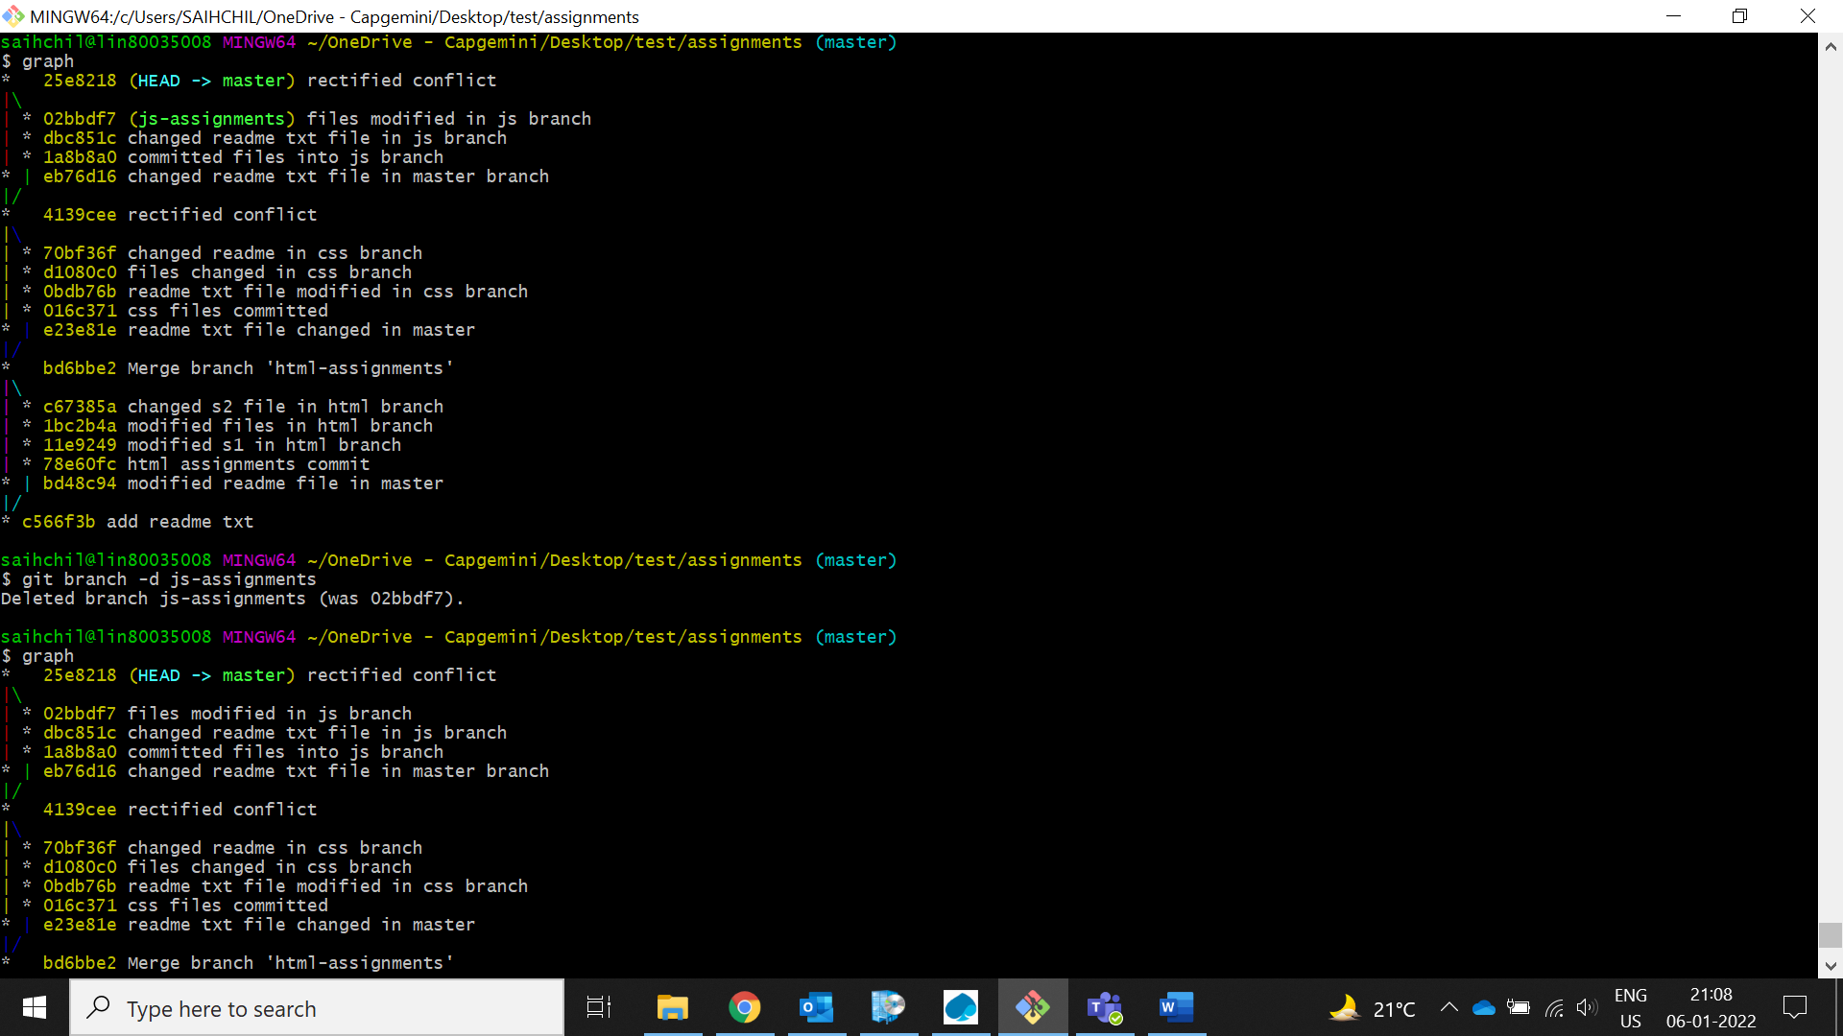

*GIT Remoting*

Objective: Pushing source code into GITHUB & collaborate team members.

SECTION-3 (Pushing assignments to remote repository) - Steps to follow:

1. **Create a github account if you do not have already.** Done
2. **Login on into github account.** Done
3. **Create new public repository ‘freshersbatch-oct16’.**

I have created a repository named as ‘Newrepo’

1. **Commit & push any sample file to this repository under ‘Assignments’ directory.**

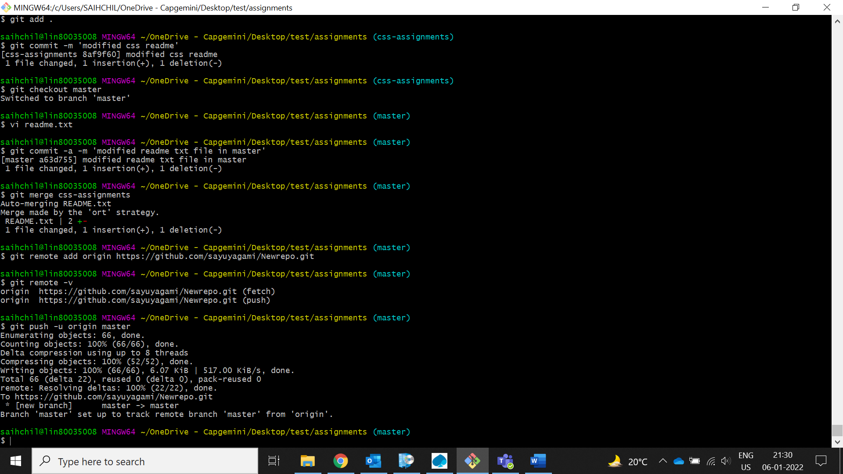

SECTION-4 (Pushing source code to remote repository using Eclipse GIT plugin) - Steps to follow:

1. **One developer from project team will create eclipse projects ‘SampleProj’ & add sample source code files. Then commit all files through eclipse GIT plugin.**

As one of the team member I took the responsibility to create a ‘SampleProj’ in eclipse and created some of the files such as with .html,.css,.js extension files and created a git repository in github. By using http link I have cloned the empty/new project into eclipse and after done with the modifications, in the end I have done the following process to push the changes to github.

**Step1: SampleProj>Team>Shareproject**

**Step2: SampleProj>Team>commit**

Here I faced some authentication problem and I solved this issue by going through StackOverFlow(https://stackoverflow.com/questions/30421875/cant-connect-to-any-uri-error-while-commiting-code-from-eclipse-to-git-reposito) I got to know that to push a project from eclipse to github you need to generate a token and use that token instead of github password.

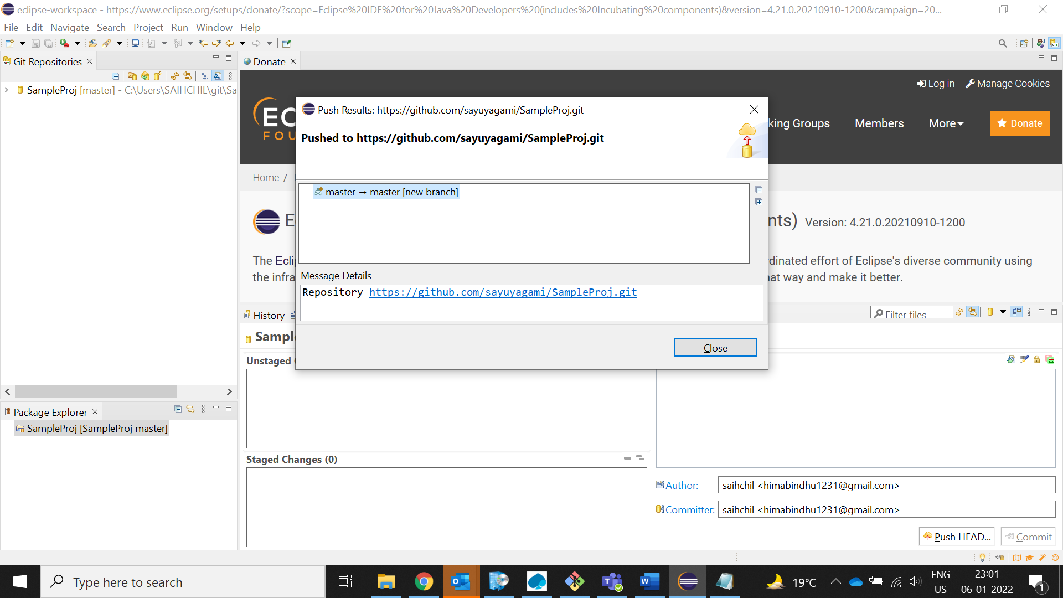

1. **Collaborate other team members with your github account so that they can also modify the committed files.**

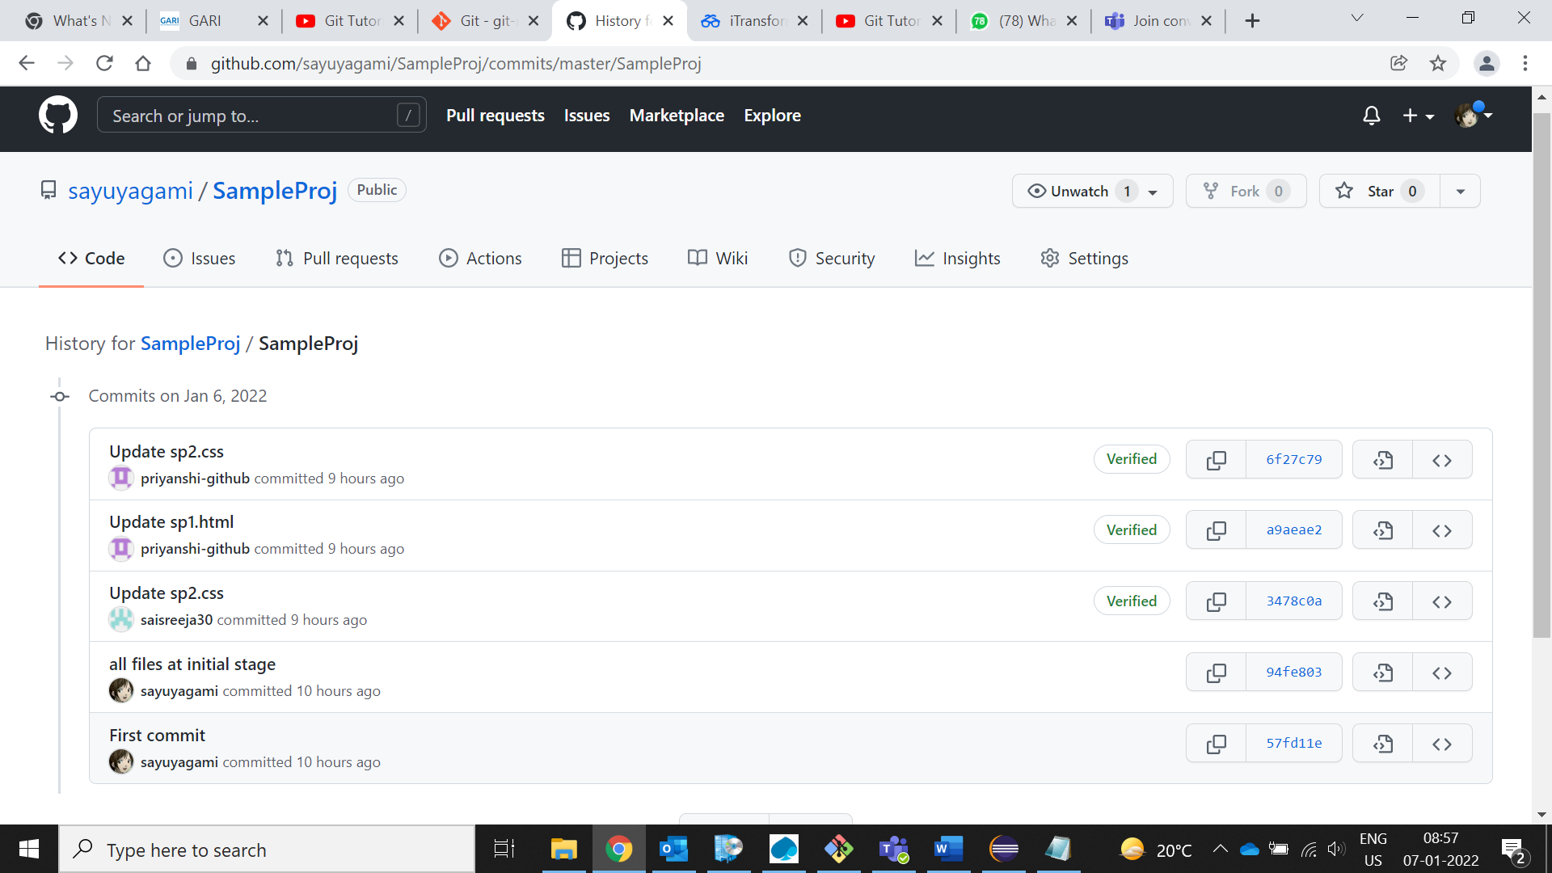

1. Other developers from same team will checkout all files from remote repository. This might get conflicts since certain files fail to merge. In such case, merge it manually.
2. Commit & push the ‘SampleProj’ project.